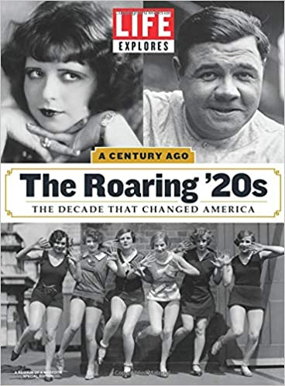

FOURTH QUARTER 2020 INVESTMENT ADVISORY REPORT
~ Plus ça change, plus c'est la même chose

We were struck by the caption on the Life Magazine cover – “The Decade That Changed America”. There’s a growing narrative suggesting that we are on the cusp of another “Roaring 20s” similar to that of a century ago. We alluded to this possibility in last quarter’s report. The parallels are striking and we’re increasingly drawn to the scenario.
Probably the most immediate similarity is the occurrence of two global pandemics. During 1918 through 1920, a severe influenza pandemic swept the globe killing an estimated 50 million people and we, of course, are in the midst of our own covid-19 pandemic. However, there are also significant differences. It was nearly 90 years before we began gaining a deeper understanding of the 1918 pandemic. In 2009, two influenza experts at the NIH coauthored an article with Dr. Anthony Fauci explaining how the current H1N1 influenza virus that was circulating at that time was actually a fourth generation descendant of the 1918 novel virus! Contrast that to today’s world of genomics and big data sequencing. On January 24, the first 3 cases of coronavirus were confirmed in France. In less than 48 hours, the Institut Pasteur had decoded the entire genome. As Bill Priest observed in the recent Barron’s Roundtable Conference, “Within weeks of identifying the new coronavirus, we had sequenced its genome, and now we have at least two vaccines available, with more on the way. To me, that is the most amazing event of 2020. (Priest goes on in the article to reference the parallels between the two decades stating that “(by) the second half of 2021, we could have a reprise of the Roaring ‘20s of a century ago”).
The narrative gets better. The Human Genome Project is over 20 years old by now. Genomics has “only” 20,000 genes to sequence and is now “mainstream” science. Recent research advances have enabled “next generation sequencing instruments” that can study the transcriptome – the collection of RNA molecules in an organism with 100,000 unique molecules to sequence. And coming to a lab near you in the near future will be “next-generation protein sequencing”. This will aid the development of Proteomics which involves the study of the three-dimensional structure and sequence of protein molecules. The proteome could have upwards of 1,000,000 unique molecules and is constantly changing inside our bodies! The advances in health care and in the fight against disease that this will enable are simply mindboggling.
The profound scope of current advances in technology is brilliantly displayed in the image below created by ARK Investment Management, LLC in a “Big Ideas” white paper. It aptly highlights the technology boom of the 1920’s and compares it with the innovation occurring now. Note that much of the advances of innovation are in areas that we are just beginning to be able to experience.
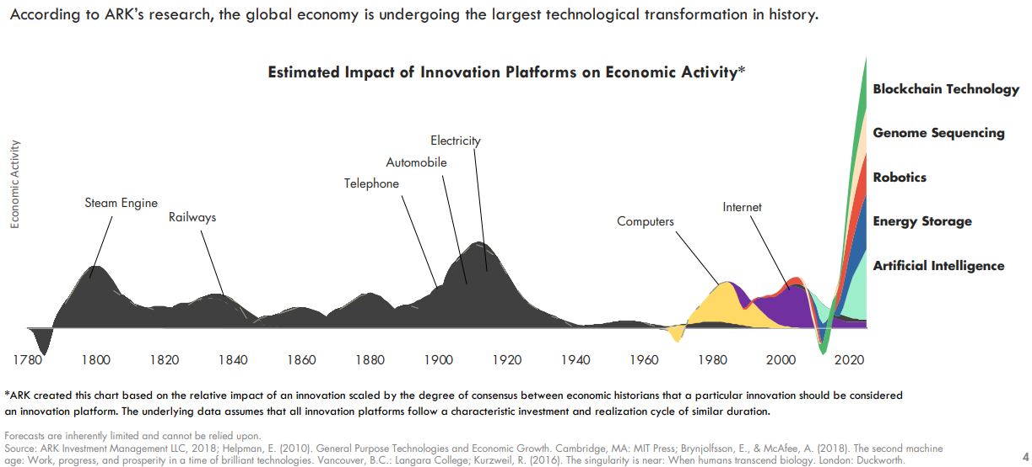
There are many other parallels that can be found in technological innovation (and the resulting economic and societal disruption). The radio was used early on in the 1900’s but in 1920, the first commercial radio station, KDKA, was developed. Over that decade stations popped up all over the world, enabling immediate mass communication. Today, we have 5G networks, financial transactions conducted over hand held mobile devices, and Zoom meetings that can be initiated within minutes and conducted on those same mobile devices. In the 1920’s advances in technology ushered in the age of electricity that powered our industrial cities and allowed for the widespread production of things like automobiles, refrigerators, washing machines, and radios. The assembly line had recently been invented by Henry Ford which exponentially reduced the time needed to produce these products.
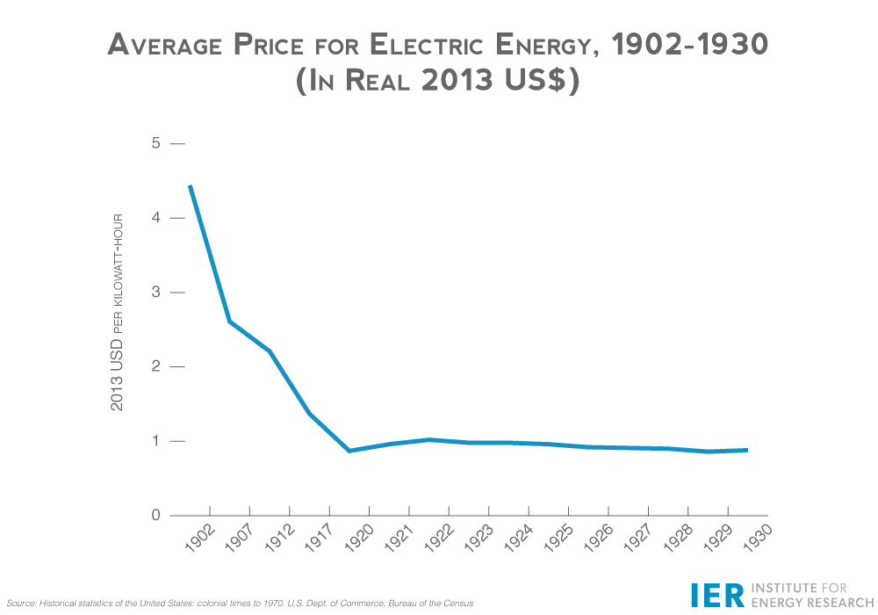
The chart above shows the dramatic decline in the cost of electricity that fueled this productivity boom.
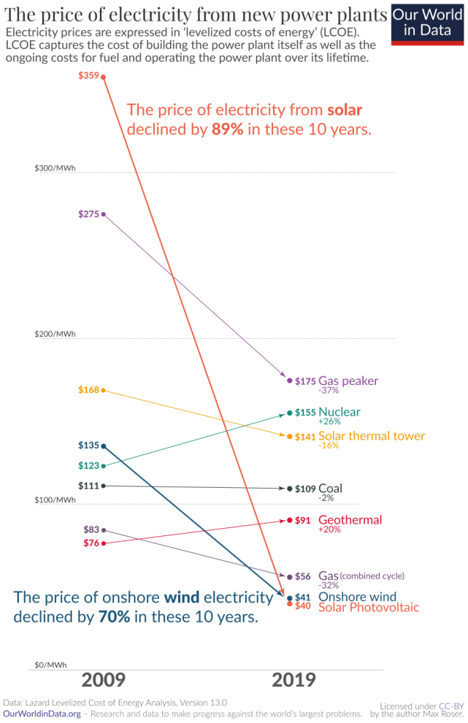
Now compare the above graph with the one on the left showing trends in the cost to generate electricity from renewable sources. In particular, note the trends in Onshore Wind and Solar Photovoltaic. GE recently developed a new wind turbine called Haliade-X which according to them is “the most powerful offshore wind turbine in the world. The Haliade-X is also the most efficient ocean-based wind platform, with a leading capacity factor of 60-64%...One Haliade-X 14 MW turbine can generate up to 74 GWh of gross annual energy production, saving up to 52,000 metric tons of CO2, which is the equivalent of the emissions generated by 11,000 vehicles* in one year.” According to the NY Times, “The G.E. machines will have a generating capacity that would have been almost unimaginable a decade ago. A single one will be able to turn out 13 megawatts of power, enough to light up a town of roughly 12,000 homes.”
In both decades, the wondrous advances in technology played a role in transforming life and society in ways that were previously unimaginable. But there were other profoundly significant parallels as well. Past Quarterly reports have discussed at length the growing inequality and concentration of wealth distribution in this country. We’ve shown how real wages have been relatively stagnant for the past four decades, how a greater and greater percentage of real income levels are being generated by government transfer payments, and how an unintended consequence of central bank bailouts and credit expansion has been an ever increasing flow of funds into financial assets which serve to concentrate wealth ever more in the hands of the already wealthy. A recent Barron’s column quoted Rockefeller Foundation President Raj Shah who explained that, “A widening wealth gap has been a deepening challenge, worsened by the pandemic. Some 2,200 billionaires saw their net worth grow by $2 trillion in 2020, while 435 million people in low-income communities around the world lost ground”.
Attempting to explain the phenomena of the Roaring ‘20’s and the subsequent Great Depression, one historian wrote:
“A poor distribution of income compounded the country's economic problems. During the 1920s, there was a pronounced shift in wealth and income toward the very rich. Between 1919 and 1929, the share of income received by the wealthiest one percent of Americans rose from 12 percent to 19 percent, while the share received by the richest five percent jumped from 24 percent to 34 percent. Over the same period, the poorest 93 percent of the non-farm population actually saw its disposable income fall… (As a result), there was insufficient demand to keep employment and investment at a high level.
Even before the onset of the Depression, business investment had begun to decline… During the mid-1920s, manufacturers expanded their production capacity and built up excessive inventories. At the decade's end they cut back sharply, directing their surplus funds into stock market speculation.”
Companies today may not be using their earnings to speculate in the stock markets, but their levels of spending on purchasing their own shares has been skyrocketing (often funded by the issuance of debt – another unintended consequence of the Fed’s zero percent interest rate policies). According to Wolf Richter, “(since) the beginning of 2012, the S&P 500 companies have bought back nearly $5 trillion of their own shares… These $5 trillion could have been invested in expansion projects in the US, and in labor, and in training, or God forbid, in reducing the debt that Corporate America has loaded up on in a historic manner.”
A recent Forbes article noted “’U.S. wealth concentration seems to have returned to levels last seen during the Roaring Twenties,’ wrote Gabriel Zucman, an economics professor at the University of California, Berkeley… In 1929 — before Wall Street’s crash unleashed the Great Depression — the top 0.1% richest adults’ share of total household wealth was close to 25%, according to Zucman’s paper, which was distributed by the National Bureau of Economic Research.”
This event is depicted in the cartoon below from the Los Angeles Times in 1928. According to the authors, “The 1920s were considered the Roaring Twenties because Americans believed that the economy was booming and people were making more money than ever before. However, this notion was incorrect. The reality was that: ‘The top 1% of wealthy Americans saw their incomes increase by 75% during the 1920s... The other 99% of Americans saw their income increase by only 9%...’”
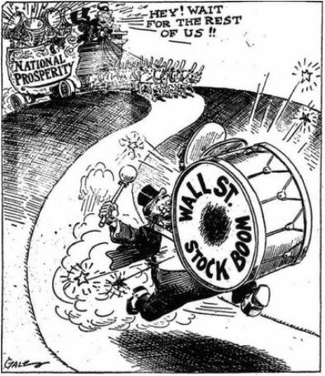
And, this is a global phenomenon. According to Zucman, “…all the research on the issue also points to large wealth concentrations in China and Russia in recent decades. The same thing is happening in France and the U.K., but at a “more moderate rise,” the paper said.”
Looking to history for direction is less than reassuring. Drawing parallels with Europe is tenuous because they were so deeply influenced by World War I, but the picture was not pretty. “…in Europe, Britain and France faced crippling war debts, deep economic recession and high unemployment. In Britain, poor labour relations even led to a short General Strike in 1926. France had the added challenge of rebuilding its economy… Italy…had been particularly hard hit by the war. Unrest became widespread in the industrial towns, and a real fear of communist revolution spread through the country.” And, the history of Germany is too well known. “The harsh conditions of the Treaty of Versailles…and the fact that the blame for the war was laid exclusively at the door of Germany, deeply embittered the German people. They faced more difficulties when hyper-inflation in 1923 destroyed the wealth of much of the middle classes.”
Again, we don’t want to over-belabor the parallels. The world today is a far cry from the wreck that Europe was after the War. But the social unease bubbling up in our society is real and, to our eyes, is growing. The protests for “Black Lives Matter”, the attempted kidnapping of Gretchen Whitmer, the Governor of Michigan, violence and looting from Atlanta to Boston to Chicago, Dallas, Los Angeles, Portland…these all happened in 2020. The most recent manifestation is in the pyrotechnics surrounding GameStop (GME) and other heavily shorted stocks. We’ll sidestep the technical aspects – other than to opine that it will probably not end well for most of the participants in this squeeze (and certainly not for the hedge funds that were short these insanely over-shorted stocks). But we could not help but be struck by the sentiment expressed by many of the new-found short sellers following various chat boards where they are being directed to simply hold GME longs and 'deprive' hedge funds of shares to cover their shares. Here’s one (of many) we came across in a blogsite:
This is for you, Dad.
I remember when the housing collapse sent a torpedo through my family. My father's concrete company collapsed almost overnight. My father lost his home. My uncle lost his home. I remember my brother helping my father count pocket change on our kitchen table. That was all the money he had left in the world. While this was happening in my home, I saw hedge funders literally drinking champagne as they looked down on the Occupy Wall Street protestors. I will never forget that.
It goes on, but the point is clear. How many people’s lives were adversely affected and ill served by the financial and socio-economic events of the past couple of decades is hard to quantify, but on many, many levels, it probably runs deeper than most are aware. And, it is real, and we are seeing the consequences.
Sandwiched in between all of this are the markets, and astoundingly, we see no change in the upward trends we’ve experienced for the past years. Cathie Wood, the founder and CEO of ARK Invest has said that she believed that “innovation” has been underpriced by the markets. That’s less true today, after the enormous run-ups some of her stock picks have enjoyed, but she makes a brilliant observation. Some would argue that it’s not as much mispricing of the inherent value as much as mispricing of sanity, as the chart below from Wolf Richter of Tesla’s stock price would argue:
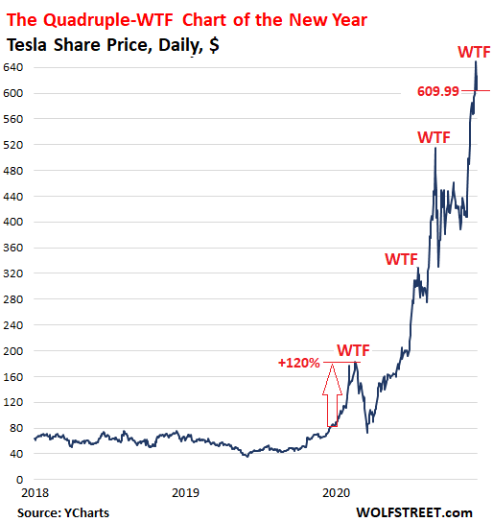
In the title of his article, Richter states “Tesla, Quadruple-WTF Chart of the Year: It Should Just Sell Shares on Autopilot at Huge Prices and Exit Sordid Business of Making Cars”. Cathie Wood would reply that the stock is going much higher.
Much of the market gains have in fact been driven by outsized gains in a few large technology names. However, as Ed Yardeni points out, if you strip out some of the “FAANGM” names from the broader index, it’s hard to argue that the overall market is overpriced”:
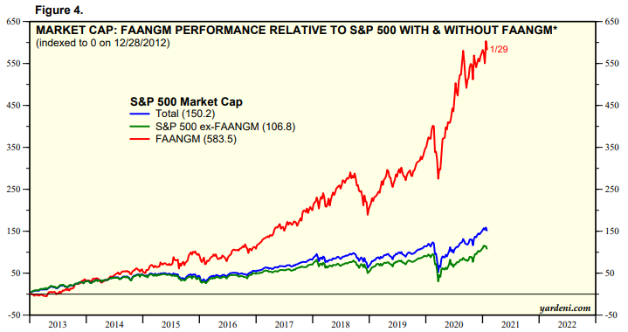

Perhaps the debate between overvalued or not is moot, because the central banks continue to go full guns ahead with their addition of global liquidity. According to Morgan Stanley forecasts, as reported by Zerohedge, it’s nothing but more balance sheet expansion as far as the eye can see (or, at least until 2022!):
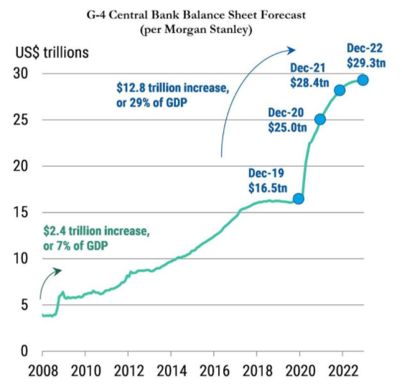
Further, the Treasury Cash Balance Account at the Fed is at an unprecedented $1.6 trillion and this will be spent down as we approach the debt ceiling deadline this summer (there are technical reasons for this, but suffice it to say, the enormity of this liquidity infusion is depicted below and it will amount to another $1.3 trillion being added into the system).
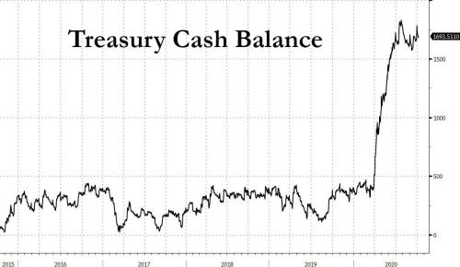

We want to reiterate that again, this is not simply a difference between Democrats and Republicans, Left vs. Right, liberal vs. conservative – it is so much deeper and more complicated than that. Nor is it an inexorable downward spiral into dystopia. The current strife needs to be juxtaposed with the technological advances described in the beginning of this report and it is our belief that the Hegelian dialectical outcome will leave us in a much better place. But it could be a very rocky journey getting there. After already experiencing 3 separate “once in 100 years” market events in just the first two decades of this century, it hardly seems a stretch to predict more of the same (although we hope we can be ridiculed in the future for how wrong we were). Meanwhile, we are watching events as they unfold each and every day in order to protect your assets as well as our own, which are invested side by side. We have faith that we will emerge from this stronger and wiser and hopefully in a more equitable and compassionate world.
Thanks for reading,

Jason

TIME-LIFE The Roaring '20s: The Decade That Changed America by TIME LIFE - 2017-1-6 SIP and Meredith | Jan 6, 2017
https://www.washingtonpost.com/history/2020/09/01/1918-flu-pandemic-end/
https://www.sciencedaily.com/releases/2020/01/200131114748.htm
2021 Barron’s Roundtable; Barron’s; Jan. 18, 2021; pg. 29.
ARK Investment Management LLC; ARK * DISRUPT; Monday, Jan. 25, 2021.
https://research.ark-invest.com/hubfs/1_Download_Files_ARK-Invest/White_Papers/Big-Ideas-2019-ARKInvest.pdf
Op. Sit. #1.
https://www.instituteforenergyresearch.org/wp-content/uploads/2014/08/Grid-Graphic-Avg.-Price-for-Electrical-Energy1.png
https://ourworldindata.org/cheap-renewables-growth
https://www.ge.com/renewableenergy/wind-energy/offshore-wind/haliade-x-offshore-turbine#:~:text=Introducing%20Haliade%2DX%2C%20the%20most,competitive%20source%20of%20clean%20energy.
https://www.nytimes.com/2021/01/01/business/GE-wind-turbine.html?auth=login-google1tap&login=google1tap
“Tackling the Wealth Gap” by Evie Liu; Barron’s; February 1, 2021; pg.8.
http://www.digitalhistory.uh.edu/disp_textbook.cfm?smtid=2&psid=3432#:~:text=During%20the%201920s%2C%20there%20was,24%20percent%20to%2034%20percent.
https://wolfstreet.com/2020/12/17/share-buybacks-drop-42-in-q3-yoy-to-102-billion-big-tech-buffett-dominate-big-banks-are-gone-very-top-heavy-affair/
https://www.forbes.com/sites/jessecolombo/2019/02/28/americas-wealth-inequality-is-at-roaring-twenties-levels/?sh=7cc9b0772a9c
https://emilyandcarl.weebly.com/false-prosperity.html
Op. Cit. # 15.
https://www.timemaps.com/civilizations/between-world-war-i-and-ii/
https://www.zerohedge.com/personal-finance/you-dad-redditor-shares-heartbreaking-reason-destroying-short-sellers-wsb-raids
https://wolfstreet.com/2020/12/12/tesla-the-quadruple-wtf-chart-of-the-year-it-should-just-sell-shares-on-autopilot-at-huge-prices-and-exit-sordid-business-of-making-cars/
FAANGM stocks include Facebook, Amazon, Apple, Netflix, Google (Alphabet), and Microsoft. Both classes of Alphabet are included. Source: Standard & Poor’s and Yardeni Research Inc.
https://www.yardeni.com/pub/faangms.pdf
https://twitter.com/jsblokland/status/1331527199908884480
https://www.zububrothers.com/2020/11/29/the-2021-liquidity-supernova-step-aside-fed-us-treasury-will-unleash-1-3-trillion-in-liquidity/

