FOURTH QUARTER 2019 INVESTMENT ADVISORY REPORT
~ Going from Risk-On to Risk-Gone?
This quarter’s theme might be a bit late, in light of the recent coronavirus outbreak (or it might be premature as the Chinese central bank is now dumping billions of dollars of liquidity into the system, but we loved the image, in any case). As Lowry Research noted, from its low on Oct. 2, 2019 low to its Jan. 17, 2020 high, the S&P gained 14.4%. If that gain were for the entire year, it would have ranked as the twenty-fifth largest S&P gain in over the last 60 years. However, this was after only 3½ months! And, as Lowry notes, the run up was “virtually uninterrupted”
Just over a year ago, in Q IV 2018, we were on the cusp of an official bear market as many indexes had declined by 20% or more. Panicked by spreading signs of economic and market weakness, the major central banks reversed course in 2019 and once again turned on the monetary spigots. According to CBRates.com (http://www.cbrates.com/decisions.htm) there were no less than 132 rate cuts in 2019 (vs. 21 rate hikes, and the cuts have continued into 2020). The firehose of liquidity worked – at least for financial assets. As the equity CIO at T. Rowe Price observed, “I don’t think you want to stand in the way of the three major banks when they are expanding their balance sheets”.
As of this writing, the markets still show little sign of slowing down (let alone going down). Neither missiles fired at US bases in Iraq nor a spreading coronavirus are able to derail things for more than a day or so and a few percentage points! Nevertheless, as discussed below, we have significant concerns surrounding the Fed’s balance sheet as well as the real economy. And, in sharp contrast to the booming stock market, the bond and commodities markets have been trading like we’re staring straight at an impending recession. We had expected a subdued pickup in growth along with accelerating inflation – a stagflationary environment in which energy and commodities do well. We recently exited most of our energy positions and might shortly be doing the same for commodities. As discussed in previous reports, commodities have only been this cheap relative to stocks two times in the past 50 years. The chart below plots the price of commodities as measured against the US stock market going back an astounding 100 years, and really highlights the extent of the deflationary environment we are in today. But, there’s nothing written in stone that says they can’t stay this cheap for another 5 years or 50 years, and their price action says that may be the case!
The chart is interesting not just for the astounding valuation extremes that it depicts, but because after 11 years into an expansion the economy typically is running up against constraints and shortages. If economic growth were genuinely robust, there absolutely would be inflationary pressures by now and pressure on commodity prices. As the perennially bullish Ed Yardeni observed this past December, “While inflation in the major economies remains comatose, the global economic slowdown may be coming to an end, as more global economic indicators are showing some signs of life. However, post-bottom growth appears so far to be tracing an L-shape recovery rather than either a U-shape or V-shape one. This is consistent with our view that global growth is being weighed down by aging demographic trends and too much debt (emphasis added).”
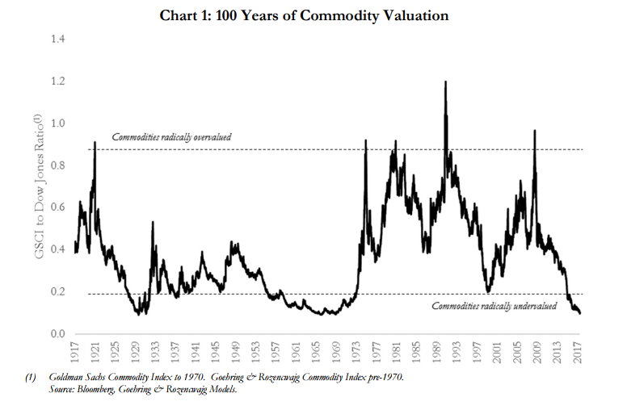
The economic rationale for the strong equity markets has been that despite softness in the manufacturing sector, the consumer remains resilient. Further, aside from TINA (there is no alternative), and absolute levels of GDP strength notwithstanding, the USA is still doing better relative to anywhere else in the world. According to data from JP Morgan, Q4 2019 GDP growth met expectations at +2.1% quarter over quarter. For the 2019 year overall though, growth slowed to 2.3%, down from 2.9% in 2018. As the temporary boost from the tax cuts receded, consumption also slowed – to 1.8% in Q4, down from 3.2% and 4.6% in Q3 and Q2 respectively. The tax cuts also failed to boost business investment, which also contracted for the past 3 quarters. Finally, the bank’s report notes that, due to a quirk in the accounting for net exports, GDP was actually even weaker than stated. The trade deficit improved, which boosts reported GDP, but this was due to a sharp decline in imports, which are actually a symptom of a retrenching consumer.
The image below starkly depicts the disconnect between the real economy and the financial markets. The red and green lines, reflecting services and manufacturing activities respectively, have rolled over to the downside, despite the fiscal and monetary stimulus, while the S&P marches relentlessly higher.
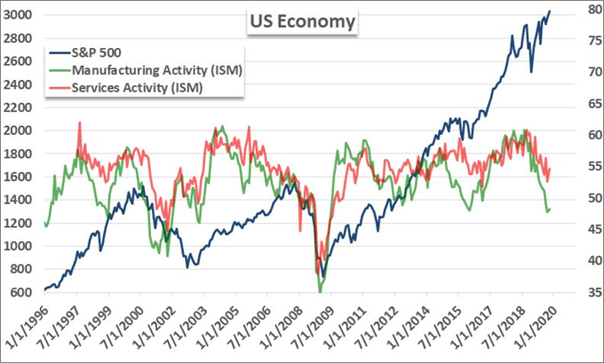

With unemployment at multi-decade lows, conventional wisdom says that the consumer is strong and will sustain the economy. What’s also strong is consumer credit which, at 19.3% of GDP, is at its highest levels ever. As Wolf Richter observes, a large portion of this is student loan debt which has its own special dynamics. And, he notes that Americans have become more prudent when it comes to credit card balances and other revolving credit. Nevertheless, the “…$187 billion increase in consumer debt in 2019 amounted to nearly a quarter of the $849 billion increase in nominal GDP over the same period. Without this $187 billion in additional spending funded by $187 billion in additional debt, the US economy would not have grown 2.3% in 2019, but only about 1.8%.” Richter offers the following two charts, which are sobering:
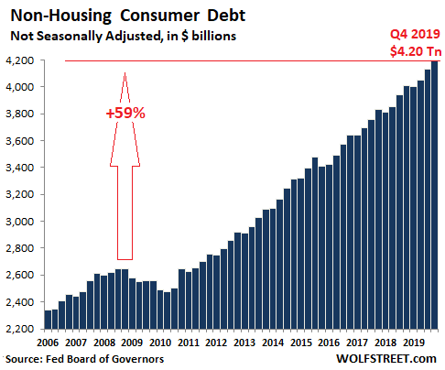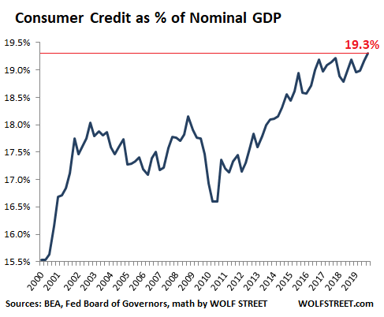
It can be argued that debt servicing is at manageable levels, and as long as interest rates remain subdued, that’s probably a valid assessment. But it raises the long debated issues of debt accumulation and at what point, if ever, does it become a problem. It’s been our long-held view that it’s not the real economy driving financial markets as much as it’s central bank balance sheets and the liquidity they provide. The Fed has shown that it can “fix” financial markets but has so far been unsuccessful in fixing the real economy (nor is it necessarily their mandate to do so). In addition to the above mentioned central bank easing in 2019, the Fed has recently taken additional steps to address problems in the “repo” funding markets. According to the Brookings Institute, “The repurchase agreement, or ‘repo,’ market is an obscure but important part of the financial system…(where) on average, $2 trillion to $4 trillion in repurchase agreements – collateralized short-term loans – are traded each day.” This market is an essential funding marketplace for financial entities such as the bond-dealer community, hedge funds, banks, asset managers and so on. It is also an essential conduit through which the Fed conducts their monetary policy. This past October, the Fed announced it would begin adding at least $60 billion per month into the system to insure adequate liquidity.
Ever sensitive to charges of interfering with the normal functioning of the markets, Fed Chairman Jerome Powell, in an Oct. 8 speech to the National Association of Business Economists in Denver, said “I want to emphasize that growth of our balance sheet for reserve management purposes should in no way be confused with the large-scale asset purchase programs that we deployed after the financial crisis. Neither the recent technical issues nor the purchases of Treasury bills we are contemplating to resolve them should materially affect the stance of monetary policy...” This led to pundits talking about the Fed’s new “Not QE” monetary policy.
As mentioned, after the market swooned at the end of 2018, the Fed abandoned their attempt to normalize their balance sheet, and backed away from their policy of raising interest rates and draining liquidity. The chart below shows that in their efforts to calm down the repo market, not only did the Fed erase nearly all of their previous tightening, but they did it at an extremely rapid rate of change.
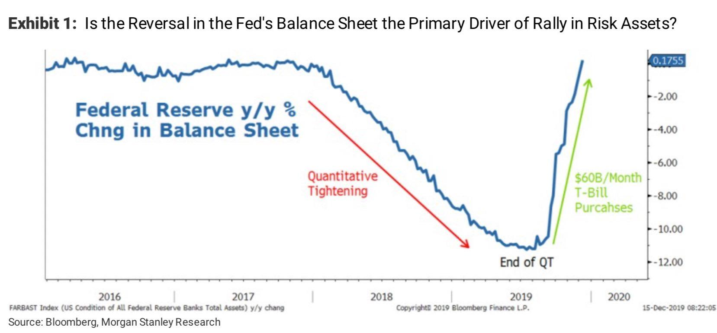
In a graph titled “The Fed Has Employed ‘Not QE’ To Address the Domestic and Global Dollar Shortage at a Record Pace,” a Hedgeye research report noted that “The last time the Fed's balance sheet was expanding as rapidly as it is today was during QE 3.” In fact, it was this very expansion of their balance sheet and their attempt to provide US Dollar liquidity to the system that prompted our call for a stagflationary environment. In a recent blog titled “You better believe the Fed is doing quantitative easing — and here are the beneficiaries”, Ivan Martchev notes that “The Federal Reserve’s balance sheet is on track to rise to a record high by mid-2020, creating a fertile ground for risk assets”. The chart below from Mauldin Economics, shows the performance of several Emerging Markets (considered a more volatile part of the risk spectrum and are positively correlated with commodities) since the Fed began shoring up the repo market.
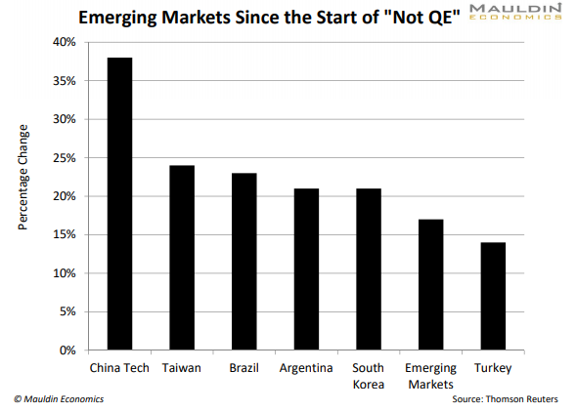
They note further,” You can also see the effects of QE in the stock market. The S&P 500 has jumped 16% since the Fed started its “Not QE.” And emerging markets—which also rally when the Fed loosens monetary policy—have also rallied, shown in the chart (above).”
Regardless of what they say, it’s more important to watch what they do. The Fed is almost certainly aware (at least one hopes) of the impact that expanding their balance sheet has on financial assets. The Fed’s main immediate concern regarding the repo market was calming the frictions that occur at the end of each quarter –and particularly at year end – as financial institutions have to “square up” their books. This is a legitimate concern, but having successfully calmed the markets through their yearend challenges, the Fed set about trying to reverse policy and soak up the excess liquidity they’d just created.
According to Richter, “Total repos on the Fed’s balance sheet of February 5, released Thursday afternoon, have plunged by $85 billion from the peak on January 1, to $170 billion, below where they’d first been on October 2:”
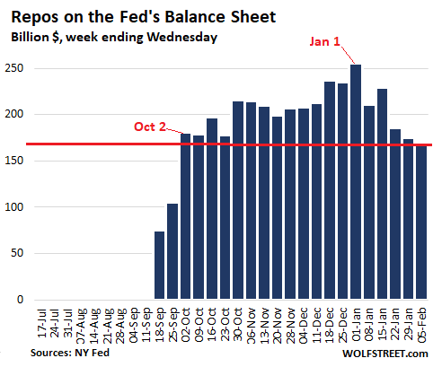
Richter concludes, “Between mid-September, 2019, and January 1, 2020, the Fed added nearly $410 billion to its balance sheet – a huge amount in just three-and-a-half months. The Fed was panicking about the repo market turmoil that threatened to blow up some of its darling hedge funds and mortgage REITs that borrow in the repo market – that have to borrow in the repo market because they’ve been borrowing in the repo market for years and cannot suddenly find alternate sources of cash. And if they run out of cash, they blow up. And rather than let capitalism do its thing with those risk-takers, the Fed stepped in and bailed out its cronies with over $400 billion. But now this task has been accomplished. And QE-4 appears to have ended.”
The results took s few weeks but were predictable. On Friday, Jan. 24, the S&P 500 opened at 3333.10. By the close the next Friday, Jan. 31, the S&P had dropped over 100 points to 3225.52, a drop of over 3% in a week! But, riding to the rescue was the Chinese central bank (PBOC) who, in response to the economic turmoil caused by the coronavirus pandemic, has been adding billions of dollars of liquidity into their system (technically, they’re adding Yuan [CNY] but by adding CNY they are expanding their own balance sheet and the effect globally, is identical to the Fed’s balance sheet expansion). According to Marketwatch, “Earlier this week, China’s central bank injected 1.7 trillion yuan ($243.88 billion) of liquidity into the financial system.” The results can be seen below in this chart from Hedgeye Research.
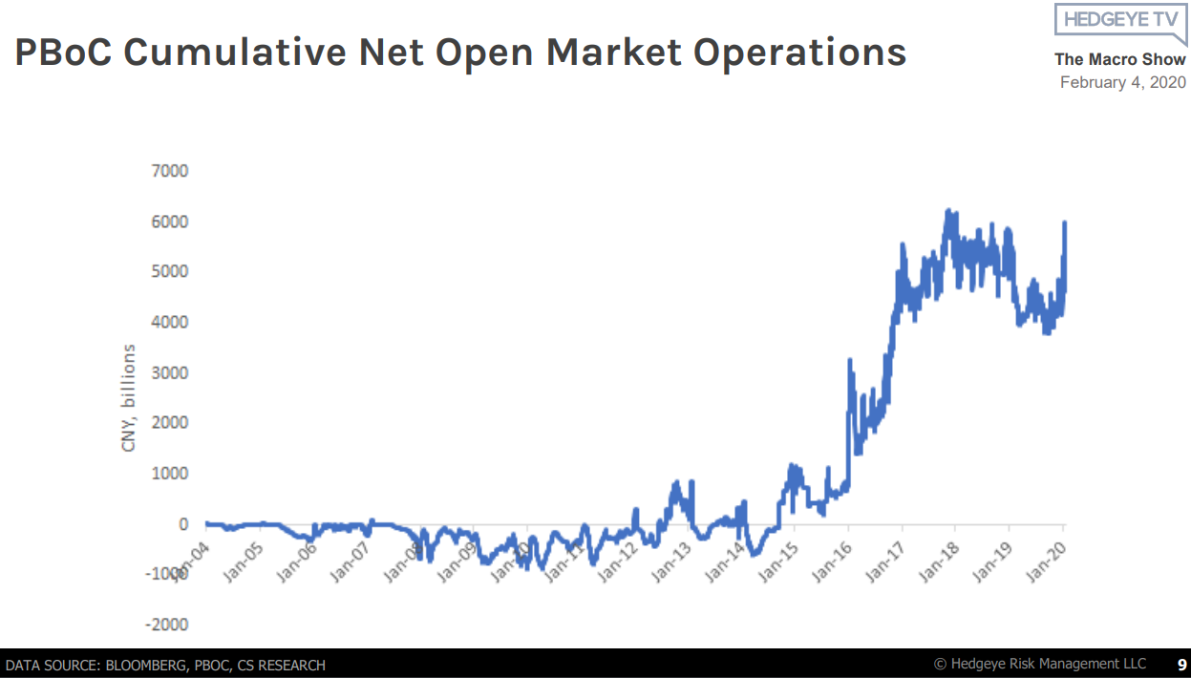

A fair question is: does any of this really matter? Why the concern about the inexorable buildup of debt in every aspect of our economy and society? It’s hard to count the ways, but a good start would be the work done by Ken Rogoff and Carmen Reinhart (e.g. “Growth in a Time of Debt”) where they argue that when a countries debt reaches high enough levels relative to their GDP, it becomes deflationary and actually retards growth. The chart below from Trading Economics shows that US Federal debt has been greater than 100% of GDP since 2012, and growing!
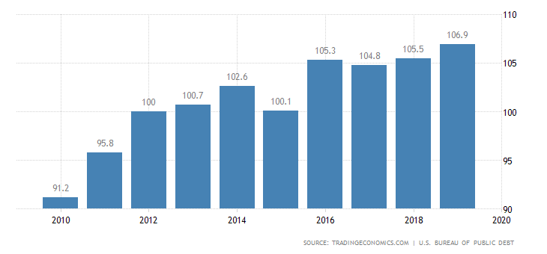
The fact that one of the largest purchasers of this debt, issued by the US Treasury, is the US Federal Reserve is possibly another cause for concern. The government issues the debt and then buys the debt (…and some people claim the government’s inefficient)! But it gets better! At the same time that US corporations have been issuing record amounts of debt (in large part used to finance stock repurchases), the level of “dealer inventories” – i.e. the amount of these bonds that dealers are willing to hold on their books – have nearly evaporated (see the chart below on the left, from JP Morgan). Thus, it’s easy to buy these bonds, but selling them will beg the question: to whom?
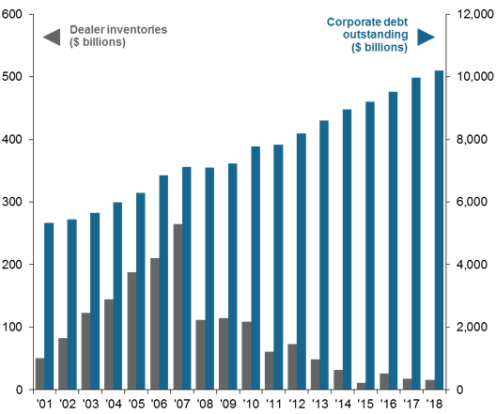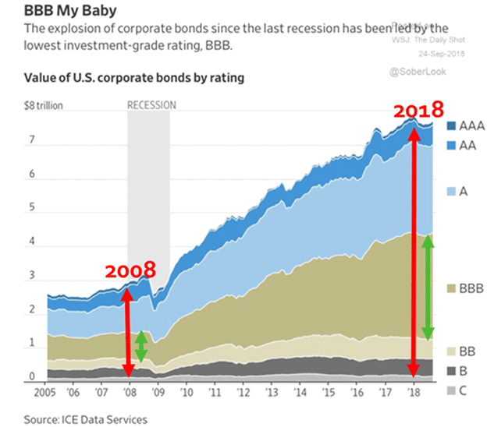
The second chart (from Mauldin Economics) shows that as the outstanding quantity of bonds have been increasing, the overall credit quality has been decreasing. What could possibly go wrong? We cannot leave you on such a dour note, however. The final chart, from Tom Bowley at StockCharts, actually paints a bullish picture – at least for the stock markets. It is presented logarithmically and goes back over the past 40 years.
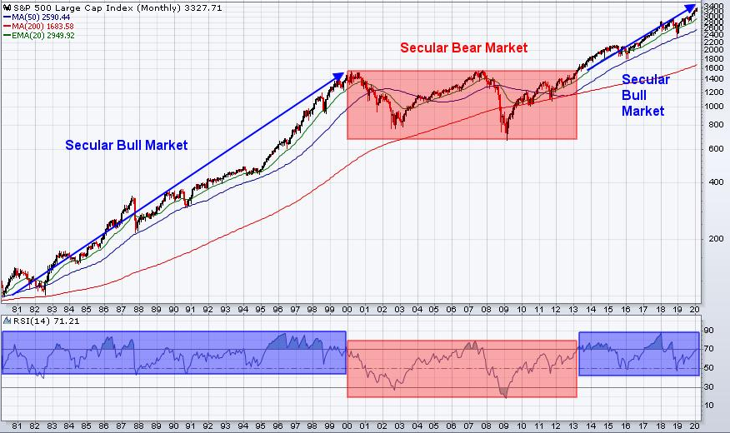

It clearly shows that we are in a secular bull market. Bowley does not promise a smooth ride straight up, but the trend is clear. It will, in our opinion, mandate the continued acquiescence of the global central banks. Perhaps we even get some cooperation from governments in the form of infrastructure/fiscal spending. In our opinion, the bond and commodity markets – which are both indicating a global growth slowdown – are attempting to “force” the Fed’s hand. We believe that growth is in fact slowing (which bonds love), the rallying bond market will once again cause a flattening of the yield curve, and the Fed’s next move will be to lower the overnight rate. Where or when it ends is anyone’s guess. We have not even touched upon politics and the effects of the upcoming election in November should be a doozy! But, as our aging marathon runner on the cover of our last report indicated, the run can go on for much longer than one would suspect.

Thanks for reading,

Jason

Lowry Market Trend Analysis; Lowry Research Corp.; Week Ending Jan. 24, 2020; pg.1
“Comfortable With the Uncomfortable”, T. Rowe Price 2020 Global Market Outlook; Dec. 2019; pg. 10
http://blog.gorozen.com/blog/commodities-at-a-100-year-low-valuation
Market View; Barron’s; Dec.9, 2019; pg. M12
Weekly Market Recap; J.P. Morgan Asset Management; U.S.; February 3, 2020
https://talkmarkets.com/content/commodities/usd-spikes-gold-sinks-as-ism-services-pmi-tops-estimates?post=239649
https://wolfstreet.com/2020/02/07/the-state-of-the-american-debt-slaves-q4-2019/
https://www.brookings.edu/blog/up-front/2020/01/28/what-is-the-repo-market-and-why-does-it-matter/
https://www.federalreserve.gov/newsevents/speech/powell20191008a.htm
https://realmoney.thestreet.com/investing/the-most-effective-market-advice-is-just-4-words-15193766
Market Edges: “Front-Running the Quants”;
https://www.marketwatch.com/story/you-better-believe-the-fed-is-doing-quantitative-easing-and-here-are-the-beneficiaries-2019-11-20
Over my Shoulder, Charts That Matter; Mauldin Economics; Jan. 29, 2020; pg. 3
https://wolfstreet.com/2020/02/07/end-of-qe-4-feds-repos-drop-to-oct-2-level-t-bills-balloon-mbs-fall-total-assets-down-to-dec-25-level/
Data from Worden Bros. TC2000.
https://www.marketwatch.com/story/coronavirus-to-cause-temporary-disruption-to-chinas-economy-pboc-says-2020-02-07-21031729
The Macro Show, “Macro Grind”, Feb. 4, 2020
https://tradingeconomics.com/united-states/government-debt-to-gdp
https://am.jpmorgan.com/us/en/asset-management/gim/adv/insights/is-bond-market-liquidity-a-problem
https://www.hvst.com/posts/mauldin-my-2019-economic-outlook-XD9TayQM

