FOURTH QUARTER 2018 ADVISORY INVESTMENT REPORT
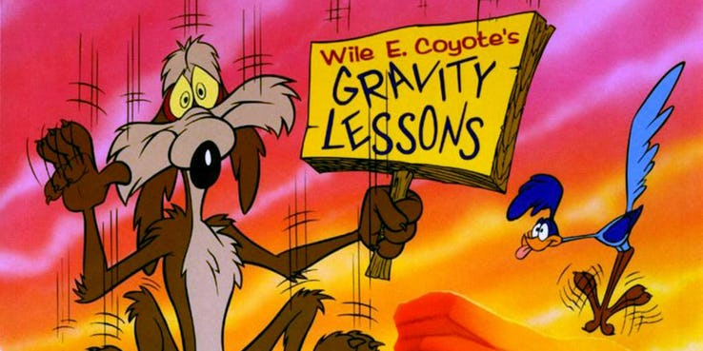

The markets got a Wile E. Coyote lesson in gravity in the fourth quarter of 2018! As T. Rowe Price noted, “The major indexes suffered their worst quarterly declines in roughly a decade, returning most benchmarks to levels last seen in the summer of 2017 and sending them into bear market territory, or down more than 20% from their recent highs.” In addition, volatility returned in a big way – both to the downside as well as the upside. On December 26th, for example, the Dow Jones Industrial index swung from a low print of 21,712.53 to a high of 22,878.92, a move up of over 1,000 points!
Ironically, the economic environment in 2018 was basically benign. Growth was decent – aided in part by the recent 2017 tax cuts - and earnings were stellar with 2018 earnings per share growth of 22.6.% year over year.
At the same time, there was no shortage of events to be concerned about. Globally, these ranged from Brexit, to ongoing trade conflicts and tariffs, Italian politics, protests in France, a sharp slowdown in Eurozone business confidence, a deceleration of growth in China, along with a government shutdown in the US, just to name a few.
To us, the main event was the threat of less accommodative Central Banks. In the US, the Fed raised rates 4 times in 2018 (making it the 9th hike since the Fed began moving rates up from zero in December of 2015), the last hike occurring on December 19 which brought the fed Funds rate up to a target range of 2.25-2.50%. Of greatest import, however, was the stated goal put forth by many of the major central banks to begin reversing the expansion of their balance sheets. Quantitative Easing (QE) was to become Quantitative Tightening (QT). The European Central Bank (ECB) announced that it would cease its program of net asset purchases by the end of 2018, as did the Bank of Japan (BoJ). The Fed began selling assets in 2017.
Past reports have spoken at length about the massive expansion of the Fed’s balance sheet in response to the 2008 financial crisis. According to data from the St. Louis Fed, “As a result of the QE programs, the Fed's total assets rose from $882 billion in December 2007 to $4.473 trillion in May 2017”. In purchasing these assets the Fed channeled deposits of roughly $3.5 trillion into the US banking system. Strategies for the eventual unwinding of this were always a bit hazy, if not outright problematic. But, we got to see some of the ramifications last quarter as the S&P 500 lost roughly 13.5% of its value.
According to Richard Suttmeier, “The Federal Reserve balance sheet remains a drag: As of Jan. 23, the balance sheet was marked at $4.047 trillion, down $453 billion since the end of September 2017 ... The first drain of 2019 was just $2 billion, the second was $6 billion and the latest was $3 billion.” Essentially, the Fed is allowing roughly $50 billion of assets each month to mature and not be replaced. The effects can be seen in the chart below from a Zerohedge article entitled “This Is The One Chart Every Trader Should Have ‘Taped To Their Screen’”:

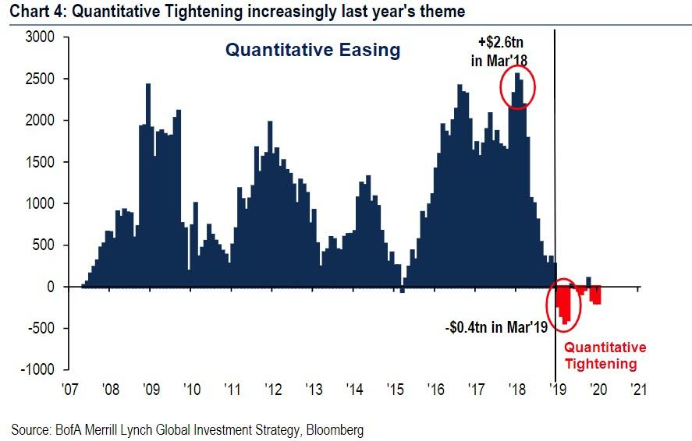
Past reports have also spoken at length about the effects of the central banks policies on currency exchange rates and in particular about our reliance on the US dollar (USD) as a barometer for global liquidity pressures. As seen above, the rate of change of the Feds holdings peaked in the beginning of 2018 and began its descent into negative territory. Right on que, the USD began strengthening as global liquidity began drying up.

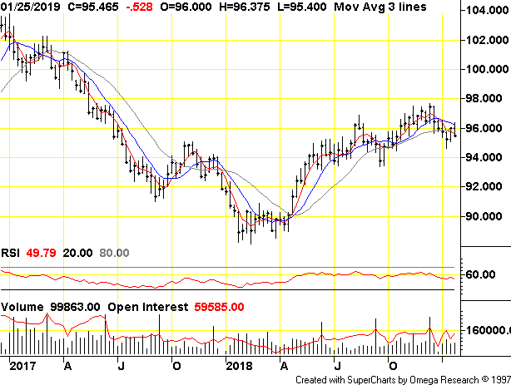
To make matters worse, as noted above, the Fed is not the only central bank hoping to walk back some of their former largesse – if only in order to have some “dry powder” for the next crisis. The next two charts, from Yardeni Research, show that the ECB has also begun reducing the size of their own balance sheet and the Bank of Japan (BoJ) has slowed their increases.

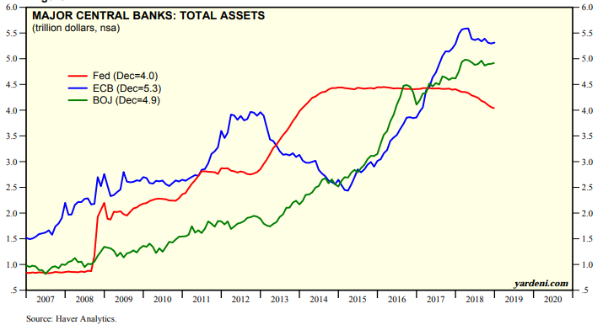

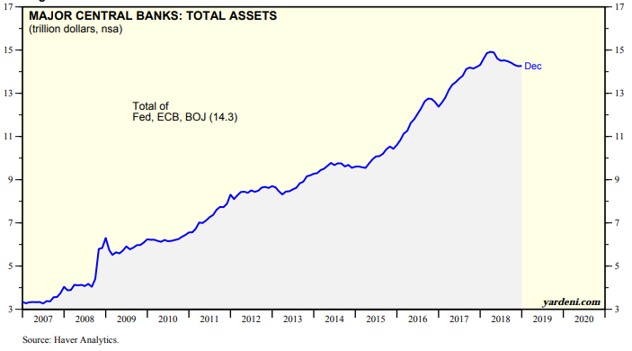
In a recent presentation from DoubleLine, Jeff Gundlach offered a neat chart that shows the correlation between the rate of growth of central bank balance sheets along with the returns on the MSCI All World stock index.
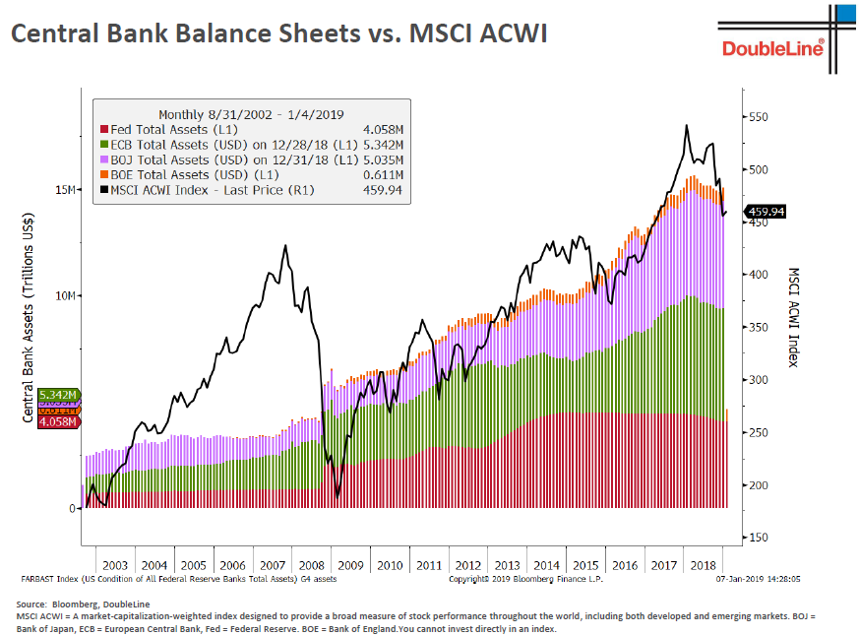

The results, as noted at the top, have not been pleasant. According to Jake Weber at Mauldin Economics, “From peak to trough, over $20 trillion of global equity market cap vanished. It took less than 11 months to wipe out 23% of equity value”.

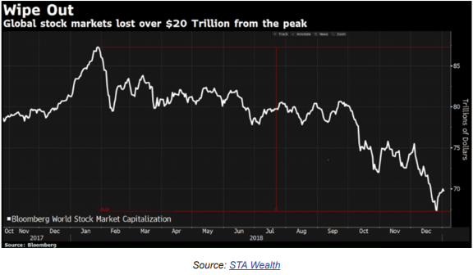
And, it was not just equities that lost value. As the next two charts show, nearly every asset class available lost value in 2018. The first chart goes back over 100 years and shows that last year more than 90% of all assets lost value – the largest percentage ever over that time period. The second chart shows the returns for various individual indexes during last quarter. For the entire year, many of these performed even worse, particularly emerging markets which were sort of the “canary in the coal mine” for all financial assets.
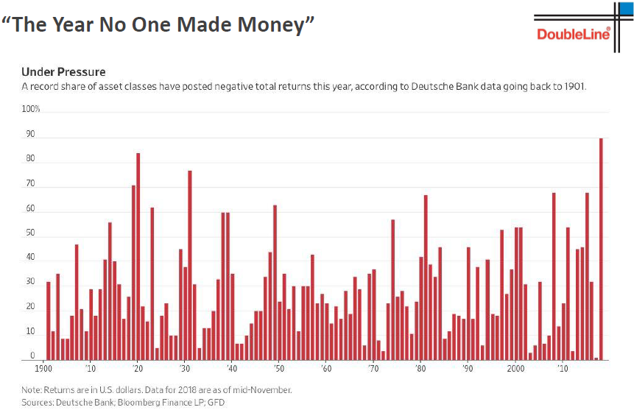
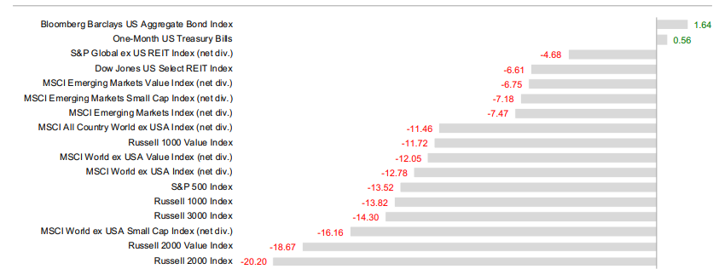

All this has not been lost on the central bankers whom we assume – whether they admit it or not – are well aware of the risks involved and find themselves painted into a very tight corner. In early January, Fed Chairman Jerome Powell said in a discussion that the Fed’s balance sheet “…will be substantially smaller than it is now”. But a mere few weeks later, Fed officials indicated that the program of QT might be nearing its end. Citing a Wall Street Journal interview, CNBC reported a quote from Kansas City Fed President Esther George concerning the balance sheet reductions. She said “A lot of the heavy lifting has been done”.
We would argue that along with “the heavy lifting”, a lot of the damage might also have already been done, as the tightening was unleashed onto a global economy that was already slowing. The strong USD exacted a particularly strong toll on emerging markets, many of whom had issued large amounts of dollar denominated debt earlier on in the cycle and were now faced with a double whammy of servicing that debt with declining revenues and a weaker currency. To protect their currencies, EM central banks must either raise interest rates which would hurt their domestic economy, or allow the currency to weaken which causes domestic inflation and makes debt servicing even harder.
Writing back in September, the Global Times reported that “Emerging market investors are trying to gauge whether a currency crisis and the steep interest rate hikes fighting it could turn into a broader slowdown or even a recession. On Thursday, Turkey's central bank attempted to draw a line under a lira collapse of almost 40 percent this year by hiking interest rates more than 6 percentage points to 24 percent. Argentina is struggling to shore up its peso, which has more than halved in value despite punitive interest rate rises to 60 percent. Other currencies have been caught in the slipstream, with India's rupee plumbing record lows and South Africa's rand, Russia's rouble and Brazil's real losing 15-20 percent this year so far. Signs are appearing that months of market turmoil are starting to take their toll on real economies. South Africa unexpectedly entered a recession in the second quarter of this year. Argentina is predicted to follow suit and Turkey is now widely forecast to experience a hard landing over the next year. “
In particular, China is slowing and that has ramifications for global growth. Chinese official data is admittedly suspect, but as seen in the next chart, even their own data depict a notable deceleration in growth. According to Trading Economics, China reported “… the lowest growth rate since the global financial crisis, amid intense trade dispute with the US, weakening domestic demand and alarming off-balance-sheet borrowings by local governments. Considering full 2018, the economy expanded 6.6 percent, the weakest pace since 1990 (emph. added)”.

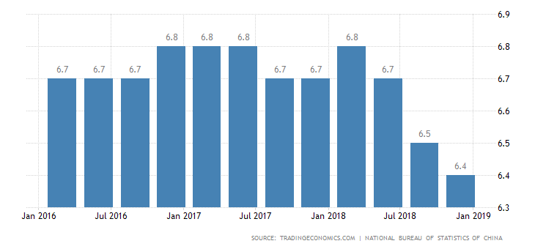
This matters a lot. Weaker Chinese demand lowers their imports from the rest of the world and weaker Chinese exports reduce demand for intermediate goods and for commodities (which hurts emerging markets). As economist Stephen Roach observed, “While recent GDP data point to only a slight deceleration in late 2018 — 6.4% annual growth in the fourth quarter versus 6.5% in the third quarter – monthly data revealed sharp declines in December retail sales of key discretionary consumption items such as automobiles and mobile phones. Reflecting this deterioration in domestic demand, Chinese imports plunged by 7.6% in the 12 months ending in December, a worrisome about-face after a 16.1% gain in 2017. At the same time, China’s exports fell 4.4% in December as tariff-related weakness in U.S. markets finally appears to be taking a meaningful toll.”
Oxford Economics estimate that “world growth could slow to a decade low of 2.3% in 2019 if Chinese growth slows sharply and could drop below 2% in the event of a combined slowdown in China and the U.S.”
All this has a major silver lining though. The central banks absolutely need to “normalize” their balance sheets and sever our dependence on endless supplies of credit. There is no easy way out of this, but as often noted, markets correct via price or time. Perhaps the unfolding slowdown will prompt the Fed bankers to proceed with their QT ever so gradually. That could extend the cycle for years. As T. Rowe Price further noted, there is no sign on the horizon of a recession – at least in the US – but because of weaker global conditions “The Fed has completed most of its anticipated tightening, making further rate hikes less of a challenge. The auto and housing sectors in the U.S. have slowed as rates have risen, but the types of distortions that are typically apparent at the end of a market cycle are conspicuously absent—providing little threat of a boom being followed by a bust. The current environment has not seen a widespread misallocation of capital and euphoria in certain sectors, such as occurred in telecom infrastructure in 1999 and housing in the mid‑2000s.”
We might take exception to that call because it is our view that there has been considerable misallocation of capital in the corporate bond markets and that shoe has yet to drop. Further, the US Federal budget deficits are set to explode as the tax cuts have yet to be paid for and as demographics dictate an aging population that will be in dire need of services. This deficit will be funded with more Government debt and this will necessarily come at the expense of other assets.
Stephen Blumenthal recently reported on a podcast featuring Louis-Vincent Gave in which he said “The U.S. government is running a $1 trillion deficit. That is, the federal government is spending $1 trillion more than it receives from tax revenue (and fees). The government is funding operations and expenses by issuing new debt. Given that the Fed is no longer printing money and no longer going to fund the increasing U.S. budget deficits, it means that the private sector has to fund it. The U.S. government will always get funded. They are like the 350-pound linebacker at the front of the buffet line who cleans up all the food and the rest of us are left to grab the scraps. And the reality is that the scraps last year weren’t big enough to push up asset prices.”
But for now, this appears to still be tomorrow’s story. In the more immediate term, the stock market is in the midst of one of its most powerful rallies in years; a “technical” condition that often portends further gains if not new all-time highs. These reports usually focus on fundamental macroeconomic issues affecting the markets and how they inform our portfolio responses. We normally do not get into technical analysis very much as it is a nuanced area, however, it is something we pay close attention to.
Lowry Research reports on these very nuances. They parse things like the relationship between trading volumes (up-volume vs. down volume, for example), the relationships among advancing and declining stocks, short term momentum spikes, sector analysis and so on. In their commentary for the week ending January 18th, they note that “In addition to (very strong up volume), the Jan. 4th rally was accompanied by very positive market breadth in which Advancing Issues were 90.8% of total Advance/Decline Issues. Since 1940, this 9:1 ratio of Advances vs. Declines has occurred only 42 times with each occurrence associated with a strong, sustained rally. This sign of market strength was then followed on Jan. 9th with evidence of a major expansion in short-term Demand through one of the strongest moves in upside momentum in the Short Term Index over the past 38 years. Once again, spikes in upside momentum have, historically, been associated with strong market rallies. A final piece of evidence supporting a strong rally appeared on Jan. 11th through a very high reading in so-called breadth momentum... Like 9:1 positive breadth and high Short Term Index momentum, these breadth thrusts are rare with only 29 occurrences since 1980. And, each has been associated with a strong, sustained rally.”
Technical analysis, like any other analysis, is only another tool. We utilize it primarily for risk management. At the end of the day, it is merely an analysis of what’s already occurred, and the fact remains that, as Yogi Berra famously said, it’s tough to make predictions, especially about the future! One of the rare instances noted above by Lowry was 1987 – a year that got off to a fabulous start but absolutely did not end that way! Nevertheless, technical analysis can give you a sense of probabilities of success or failure, and given the recent action of the market, all systems are go. Further, there’s an old adage that says “don’t fight the Fed” and the Fed appears to be on the side of the markets for now.
It’s hard to say when or where this ends. Sentiment also appears to still be negative enough (fueled by the recent performance of the markets last year) which is adding another tailwind to the market. Further, if there is any progress made on negotiations with China, that would be significantly bullish for global growth. Our view at this point however, remains that growth is slowing globally and this will soon be reflected in earnings which we believe have peaked. We therefore rebalanced our models last quarter to reduce risk slightly. We raised some cash in most portfolios, and shifted more towards “value” and away from growth. GDP figures for the 4th quarter are scheduled to be released soon and we’ll see if signs of a slowdown are confirmed. Beyond that, the USD looks like it has stabilized for now and the recent Fed reversal away from tightening should take some of the wind out of the dollar’s sails.
This could present an opportunity in the beaten down emerging markets space and commodities.
Given that we awoke to zero degree weather this morning in the Northeast, there should be plenty of demand for commodities - heating oil comes to mind! We hope you are all staying warm and enjoying the fact that the days are getting longer.

Thanks for Reading.

Jason

Quarterly Market Review

Fourth Quarter 2018
U.S. STOCKS
 | 4Q 2018 |  | Year-to-Date
Dow Jones Industrial Average | -11.31% |  | -3.48%
S&P 500 Index | -13.52 |  | -4.38
Nasdaq Composite Index | -17.54 |  | -3.88
S&P Mid-Cap 400 Index | -17.28 |  | -11.08
Russell 2000 Index | -20.20 |  | -11.01

INTERNATIONAL INDEXES
MSCI Index |  | 4Q 2018 Year-to-Date
EAFE (Europe, Australasia, Far East) |  | -12.50% -13.36%
All Country World ex-U.S.A. |  | -11.41 -13.78
EM (Emerging Markets) |  | -7.40 -14.25

GLOBAL BONDS
Index | 4Q 2018 | YTD
Bloomberg Barclays U.S. Aggregate Bond Index | -1.64% | +0.01%
J.P. Morgan Global High Yield Index | -3.95 | -2.37
Bloomberg Barclays Municipal Bond Index | +1.69 | +1.28
Bloomberg Barclays Global Aggregate Ex-U.S. Dollar Bond Index | +0.91 | -2.15
J.P. Morgan Emerging Markets Bond Index Global Diversified | -1.26 | -4.26

https://www.troweprice.com/financial-intermediary/us/en/insights/articles/2018/q4/quarterly-market-review.html?cid=BD_TP6A_BD_Play2&bid=128904226&PlacementGUID=em_USI_USI_MktActivation_Play2_MonthlyMarket_E6-BD_TP6A_BD_Play2_20190123
Data from Worden Bros. TC2000.
Nuveen; Ten Predictions 2019: Choppy and Frustrating, but no Recession; pg. 1
http://www.fedprimerate.com/fedfundsrate/federal_funds_rate_history.htm
https://www.stlouisfed.org/on-the-economy/2017/november/quantitative-easing-how-used
http://performance.morningstar.com/funds/etf/total-returns.action?t=SPY
https://seekingalpha.com/article/4235791-bear-market-rally-continues-5-equity-etfs-climb-risky-levels?ifp=0
https://www.zerohedge.com/news/2019-01-19/one-chart-every-trader-should-have-taped-their-screen
http://futures.tradingcharts.com/chart/US/W
https://www.yardeni.com/pub/peacockfedecbassets.pdf
Just Markets; Live Webcast by Jeff Gundlach; January 8, 2019
https://ggc-mauldin-images.s3.amazonaws.com/uploads/pdf/CTM_Jan_09_2019_4.pdf
Op. cit. # 11
Efficient Advisors; Q4 Quarterly Market Review; pg. 10
https://www.cnbc.com/2019/01/10/powell-says-balance-sheet-will-be-substantially-smaller.html
https://www.cnbc.com/2019/01/25/fed-reportedly-moving-closer-to-ending-balance-sheet-reduction.html
http://www.globaltimes.cn/content/1120106.shtml
https://tradingeconomics.com/china/gdp-growth-annual
https://www.marketwatch.com/story/the-slump-in-global-trade-is-a-bigger-threat-than-markets-imagine-2019-01-29
https://www.marketwatch.com/story/3-ways-chinas-pain-could-slam-the-brakes-on-global-economic-growth-2019-01-29
Op. Cit. #1
https://www.cmgwealth.com/ri/on-my-radar-more-money-than-fools-or-more-fools-than-money/
Lowry’s New York Stock Exchange Market Analysis; Weekly Report; Jan. 18, 2019; pg.1
https://www.troweprice.com/financial-intermediary/us/en/insights/articles/2018/q4/quarterly-market-review.html?cid=BD_TP6A_BD_Play2&bid=128904226&PlacementGUID=em_USI_USI_MktActivation_Play2_MonthlyMarket_E6-BD_TP6A_BD_Play2_20190123#quarterlyreview-u.s.-stocks

