SECOND QUARTER 2019 ADVISORY INVESTMENT REPORT
~ Headed to Extra Innings

First, a hat tip to State Street Global Advisors (SSGA) for the caption and picture. We feel the image perfectly captures our view of the market and of investment assets in general. In their report, SSGA notes “Now, amid what feels like an endless economic expansion and bull market, the score is all tied up after a bruising end to last year and an equally spectacular start to 2019. …investors will have to settle into their seats … because this lengthy cycle is headed into extra innings!
Further, they write that “Extraordinarily easy monetary policies and curiously timed fiscal stimulus (i.e. last year’s tax cuts; ed. note) have made it difficult for investors to pinpoint exactly where we are in the never-ending cycle, crippling many classically reliable investment approaches and asset-allocation methods. Regardless of where we may be in the cycle, with the economy still expanding, corporate profits growing, and global central bank-manufactured low interest rates and benign inflation supporting higher-than-normal valuations, investors have little choice but to own risk assets. However, the breakneck pace of this year’s early gains is likely to moderate in the second half of 2019. Microbursts of volatility are now emerging ... Investors should expect more fireworks in the second half, followed by periods of tranquility when global policymakers step in to calm markets with their reassuring quick fixes.”
While corporate profits may still be growing as SSGA notes, comparisons with prior earnings growth (which has been stellar) is becoming tougher. Add in a stronger US dollar and a slowdown in global growth, and we might well be heading for a profits recession. It is not entirely clear how stocks will respond even if we do get an earnings slowdown, however, we do agree that the pace of this year’s gains is likely to moderate and that “microbursts” of volatility will emerge. And yes, we definitely agree that low interest rates have been “manufactured” by global central banks and inflation is indeed benign (everywhere except for in the prices of financial assets)!
We’ve already had a taste of volatility microbursts in Q II as concerns over the trade wars rattled the markets, along with some early signs of economic weakening. This led to a sharp selloff in May. However, on cue, in what’s becoming an increasingly familiar playbook, the Fed made some dovish statements and all was well again. As JPMorgan reported, “In June, the central banks came to the rescue. Confronted by weaker economic data, risks to the trade outlook and still low inflation, the Federal Reserve (the Fed) and the European Central Bank (ECB) indicated that the cavalry is coming in the form of further monetary stimulus. So bad economic news was good news for markets.”
Unfortunately though, there’s no evidence that the monetary easing is really working. The chart below from the World Bank shows the gradual downward trend in US GDP going back nearly 40 years. In particular, for the past decade since the Great Financial Crisis in 2008 – and despite the massive increase in the Fed’s balance sheet – growth has failed to rise above 3%.

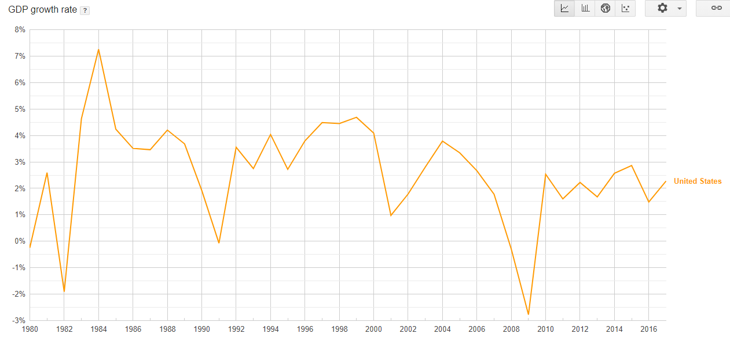
In his weekly “On My Radar” missive, Steve Blumenthal shared some of his notes from David Rosenberg’s presentation at the Mauldin Strategic Investment Conference in 2019. Rosenberg (the former chief economist at Merrill Lynch) observed “…So, everything’s going in the wrong direction except monetary policy. So, monetary policy was kept at it, you know, QE2, QE3, forward guidance, Operation Twist, negative interest rates in Europe, okay? We pulled out all the guns. The problem was that it’s been remarkably ineffective. So, we have had 10 years, I remind you …10 years of negative real interest rates in the United States and many other countries as well…and it didn’t get the economy growing again….”
Further, signs abound that growth is turning down from current levels. Part of this is likely because the positive effects of the aforementioned tax cuts are now receding. And globally, tariffs and supply chain uncertainties are clearly not helping. But most importantly, we’re probably beginning to see the lagged effects of the recent monetary tightening as central banks began reducing the massive amounts of liquidity created from their past Quantitative Easing programs. According to Hedgeye, in the 50 economies they follow, there were 575 basis points (5.75%) of tightening in 2018 (this is after netting out 1,600 points of tightening by Turkey). Fed data show that the Fed increased its balance sheet to a peak of roughly $4.5 trillion in December of 2014. As of this July, that figure has been reduced to around $3.815 trillion.
By the 4th quarter of 2018 the market had thrown a major tantrum and the tightening experiment was quickly walked back (more on this below). According to a Bloomberg story in Yahoo Finance, “The era of quantitative tightening by major central banks is proving to be short lived. Net bond purchases by the Federal Reserve, European Central Bank and Bank of Japan will swing back above zero (beginning in) September, according to an analysis of their balance sheets by Bloomberg Economics. That’s just eleven months since they collectively hit reverse having spent a decade pumping stimulus into their economies via quantitative easing.
But arguably, the damage has already been done. Recent data from IHS Markit shows that “The pace of global economic growth remained stuck at a three-year low in June…rounding off the worst quarterly expansion since the second quarter of 2016. Both employment growth and cost pressures also hit the weakest since 2016, while future business expectations sank to a new survey low.”

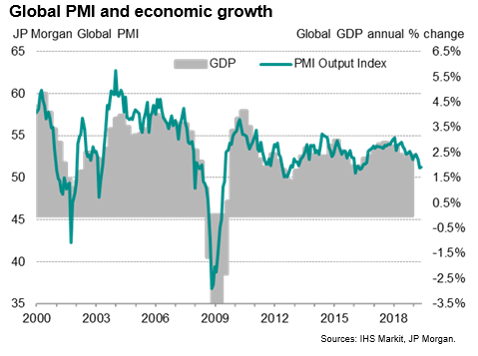
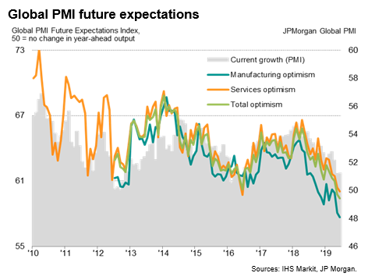
The above surveys are for total production. If we separate out just manufacturing, the picture gets even bleaker. (Note; these are diffusion indexes so that readings over 50 imply expansion and under 50 means contraction). According to Markit, Global PMI hit 49.4 in June. They note that “Only 12 of the 30 countries covered by the IHS Markit surveys reported improved business conditions, the lowest number for over six years. Deteriorating business conditions were seen in the Eurozone, UK, China, Japan and the rest of Asia. The US meanwhile remained close to stagnant, the past two months registering the worst performance seen over the past decade.”
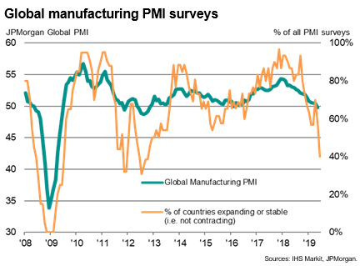
The weakness in the US can be illustrated by the volume of freight shipments (note: this includes all transportation modes). According to a report from a recent Over my Shoulder publication, absolute volumes have been falling since early 2018 and turned negative in December. “Annual freight growth has been below zero for six straight months. According to Cass, the decline is consistent across regions and modes (truck, rail, air, ship). Moreover, it appears to be getting worse. The index was below zero for a long time in 2015–2016, but the magnitude of the change was much smaller.”
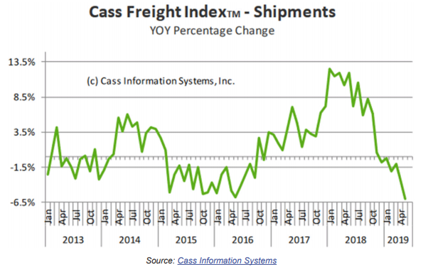
At the same time, inflation is subdued and according to Markit, “Cost pressures continued to moderate alongside the slowing global economy, with weaker demand again often cited as having diminished firms' pricing power. Input cost inflation slipped to the lowest since September 2016.

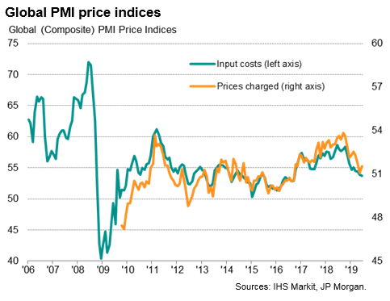
In fact, as shown in the chart below from JPMorgan, expectations for future inflation is running below the Fed funds rate, implying the Fed has leeway to lower interest rates right now.
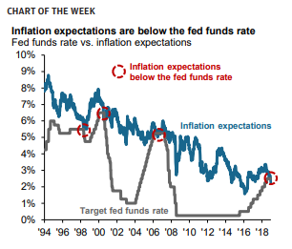
But what will more easing accomplish, aside from continuing to prop up asset values? As David Rosenberg pointed out, central bank monetary policy has been notably ineffective at stimulating economic growth, but it has been deeply effective at creating many unintended (or possibly intended) consequences. He writes “…dangerous side effects have got many manifestations. The most important one is the debt that is going to come back and bite us in the bum. But I also make the point, there is an awful lot of other imbalances have been building up over the course of the last 10 years, one of which clearly is asset prices… Financial market malfunctioning. There’s been no price discovery in many of these markets for years…in some cases in Japan there have been no trades in JGBs (Japanese Bonds) on any given day. This is extraordinary.”
We were unaware of that last point and find it way beyond extraordinary. The total value of the Japanese Government bond market (JGB’s) is around 1 quadrillion yen according to Reuters. (At current exchange rates of around 108 Yen to the US dollar, that’s a bit over $9 trillion USD). The idea that a market of this size has been so distorted by the actions of the central bank that there are days that no trades take place at all, is virtually incomprehensible. Yet the central banks continue. The bankers are obviously aware of this but they are trapped. In past reports we have noted that the last two recessions were not caused by a slowdown in the economic cycle, but rather were the result of financial events. Recent attempts in reigning in global liquidity only served to disrupt the equity markets which, if left unchecked, would most likely have been the trigger for the next recession.
As noted above in the Bloomberg analysis of the Fed’s recent Quantitative Tightening, “The outlook shows how quickly central banks have been forced to turn tail after spending much of last year leaning toward tightening monetary policy, only to now be looking to loosen it as the world economy slows. It also underscores how their balance sheets are likely to remain permanently larger than the pre-crisis years”.
The results of all this are vividly captured in the below chart in a report titled “World Adds More Leverage”. It notes that “According to Morgan Stanley, the worldwide debt-to-GDP ratio now stands at 227.2%. Take out China and it’s ‘only’ 213.4%. Both figures are down slightly from two years ago. That’s the good news. The bad news is that debt ratios are way higher than they were at the end of 2007, when we entered the Great Recession. At that point, global debt-to-GDP stood at 188.8%. That means the world is collectively about 20% more leveraged than it was when the last financial crisis struck.”
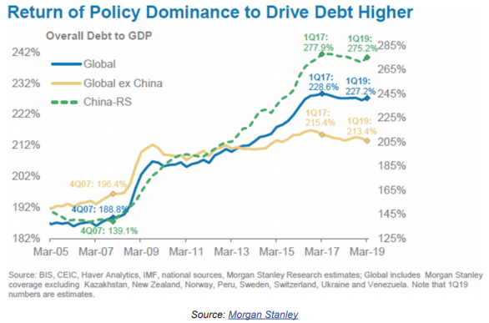
And the results are apparent in headlines such as a recent FT article entitled “Buyout Groups Hold $2Tn War Chest”. They report that “Private equity deal making has soared to its highest level since the lead-up to the global financial crisis and there is no end in sight to the buyout boom as companies chase investment opportunities for a record near-$2tn of unspent cash.” The environment was concisely summed up by the global head of financial sponsors at UBS, Simona Maellare, stating ‘Deals can be financed, competition for assets is vivid, everyone has a lot of money.’”
So the music plays on, and as Chuck Prince advised us in his now infamous interview with the FT in July of 2007 – just months before the financial markets seized up – “As long as the music is playing, you’ve got to get up and dance” To be clear though, we are not expecting another 2008 any time soon. As Ed Yardeni wrote, “…we predicted that the current expansion might last well into 2019 and maybe beyond. We still believe that ‘beyond’ is likely…Our basic thesis is ‘no boom, no bust.’ That’s one of the major lessons I learned during the first 40 years of my career on Wall Street….” Yardeni further observed that “…the next recession has been the most widely anticipated of all time. That might explain why it hasn’t happened so far.”
What could usher in the next recession would be a financial event like a serious bear market in equities. However, as we’ve seen, the Fed will not allow that. Nor, apparently, will the ECB, BoJ or the PBOC. Rick Rieder recently wrote an op-ed piece in the FT entitled “ECB Can Treat Europe’s Growth Anemia by Buying Equities” And why not? Interest rates are already negative in Europe so it’s not clear how much lower they can go or how much lower you’d want them to go! And in any case, the ECB is running out of bonds to buy! The BoJ (and other central banks such as the Swiss National Bank) have already been buying stocks to add to their balance sheet. No worry that it hasn’t worked very well for the Japanese economy. Mr. Rieder assures us that Europe is different and buying stocks is just what their economy needs! So this will probably happen. And eventually we will be hearing calls for the Fed to do the same. And, why not?
We hope you’re all enjoying your summer, avoiding the heat, and managing to take some time to relax and unwind.

Thanks for reading,

Jason

https://us.spdrs.com/en/investment-ideas/market-outlook
Ibid.; #1
https://am.jpmorgan.com/de/institutional/library/market-insights-monthly-market-review-june-2019
https://www.google.com/publicdata/explore?ds=d5bncppjof8f9_&met_y=ny_gdp_mktp_kd_zg&idim=country:IND:USA:GBR&hl=en&dl=en#!ctype=l&strail=false&bcs=d&nselm=h&met_y=ny_gdp_mktp_kd_zg&scale_y=lin&ind_y=false&rdim=region&idim=country:USA&ifdim=region&tstart=333172800000&tend=1500782400000&hl=en_US&dl=en&ind=false
https://www.cmgwealth.com/ri/on-my-radar-mauldin-strategic-investment-conference-2019-part-iii-william-r-white/ On My Radar; Steve Blumenthal; May 31, 2019; pg. 9
Hedgeye Market Edges for the Week of 7-14-19; emailed 7/15/19
https://www.federalreserve.gov/monetarypolicy/bst_recenttrends.htm
https://finance.yahoo.com/news/quantitative-tightening-end-central-banks-010000821.html
https://seekingalpha.com/article/4273460-pmi-surveys-indicate-global-economic-growth-stuck-3-year-low?isDirectRoadblock=false
Ibid. # 6
Ibid. # 6
https://seekingalpha.com/article/4273464-global-manufacturing-downturn-deepens-june?isDirectRoadblock=false
Over my Shoulder; Charts that Matter; by Mauldin Economics; July 3, 2019; pg. 2
Op. Cit. # 6
JPMorgan, Weekly Market Recap U.S. | June 17, 2019; https://am.jpmorgan.com/blob-gim/1383452890099/83456/weekly_market_recap.pdf
Op. cit. #5
https://www.reuters.com/article/us-japan-economy-boj/bank-of-japans-balance-sheet-now-larger-than-countrys-gdp-idUSKCN1NI07Z
Op. cit. #8
Over my Shoulder; Charts that Matter; by Mauldin Economics; July 3, 2019; pg.3
Buyout Groups Hold $2Tn War Chest; FT; Friday, June 28, 2019; pg. 11
https://dealbook.nytimes.com/2007/07/10/citi-chief-on-buyout-loans-were-still-dancing/
Barron’s; Market View column; July 8, 2019; pg. M12
“ECB Can Treat Europe’s Growth Anemia by Buying Equities”; FT; July 23, 2019; pg.20

