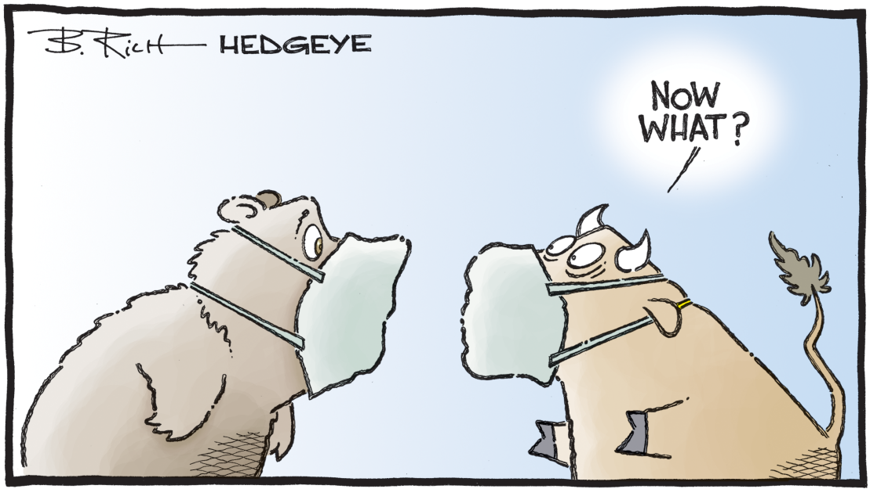

FIRST QUARTER 2020 INVESTMENT ADVISORY REPORT
~ It’s Easier to Stimulate Markets than the Economy!

It’s truly a challenge to come up with superlatives adequate to describe recent market events. As Lowry Research noted, “the 37% plunge in the DJIA in under 4 weeks puts the decline in the same conversation with the Crashes of 1929 and 1987… In fact, the eight 90% Down Days over an 18- day span represented the most intense period of selling since the 1940’s, when the market was much more illiquid and prone to frequent periods of high volatility.” However, March also saw some of the most intense up days in history. After making an intraday low of 18,213.65, the Dow Jones Industrial Index rose over 4,338 points in 3 days, for a gain of over 24%! “March, the worst month for US equities since the financial crisis, also had the best three-day stretch since the 1930s” noted Goldman Sachs. Bob Doll of Nuveen called the drop “unprecedented”, and observed that after climbing “44% from December 2018 to February 2020, stocks then dropped more than 20% in just 16 trading days making it the fastest bear market in history.” When the dust settled, according to CNBC.com, the Dow had a quarterly loss of -23.2%, its worst since the fourth quarter of 1987. It was the Dow’s worst first quarter ever. And, the S&P 500 index closed down 20%, its worst quarter since the fourth quarter of 2008. They also quote research from Bespoke Investment Group stating, “March was the S&P 500′s most volatile month ever…as frenetic swings whipsawed the market from steep gains to even steeper losses. During March, the benchmark index averaged a daily move, in either direction, of more than 4.8%.”
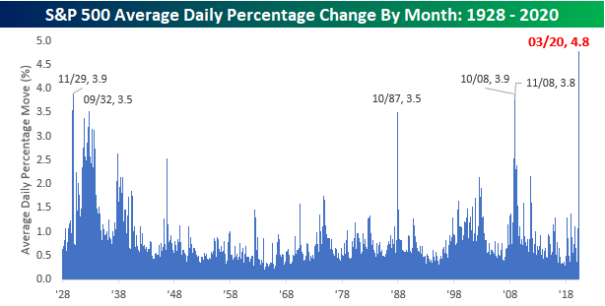
In looking ahead and trying to decipher the future, I was struck by a recent note from Howard Marks who wrote “These days everyone has the same data regarding the present and the same ignorance regarding the future…”Most of what we have today is opinion, and much of it tilts either optimistic or pessimistic. The gulf in between is massive: if you read just the optimistic pieces, you’d think the virus will soon be eradicated and the economy brought back to health, and if you read just the negative ones, you’d think we’re all done for… we have to consider our situation in the context of unprecedented uncertainty and the total absence of guidance from analogies to the past! (Emphasis added)”
We’d disagree slightly regarding a “total absence of guidance from the past.” The preconditions for recent events – at least regarding the financial markets behavior – have been discussed at length in past reports. Specifically, we’re at the tail end of a long term debt cycle dating back to the 1930’s. Further, it cannot be overemphasized that the economy was already slowing even before the coronavirus struck. In last quarters report we noted “As the perennially bullish Ed Yardeni observed this past December, ‘…while inflation in the major economies remains comatose…more global economic indicators are showing some signs of life. However, post-bottom growth appears so far to be tracing an L-shape recovery rather than either a U-shape or V-shape one. This is consistent with our view that global growth is being weighed down by aging demographic trends and too much debt’ (emphasis added).”
Regarding the “too much debt” part, we cited recent commentary from Wolf Richter concerning US consumer debt. He notes that “(although) Americans have become more prudent when it comes to credit card balances and other revolving credit, nevertheless, the ‘…$187 billion increase in consumer debt in 2019 amounted to nearly a quarter of the $849 billion increase in nominal GDP over the same period. Without this $187 billion in additional spending funded by $187 billion in additional debt, the US economy would not have grown 2.3% in 2019, but only about 1.8%.’ ”
And we could just as easily looked at US corporate debt, federal debt, state & local debt, and so on. But, let’s just skip to total global, worldwide debt, because the story is essentially the same everywhere one looks. The Institute of International Finance (IIF) is a global association of financial institutions. It was created in 1983 to address the global debt crisis of the early 1980s. Today, according to Wikipedia, they have close to 500 members from 70 countries. According to their recent reporting, “Total worldwide debt sat close to a record $253 trillion by the end of September, boosted mainly by higher borrowing by governments and non-financial corporates… Spurred by low interest rates and loose financial conditions, we estimate that total global debt will exceed $257 trillion in the first quarter of 2020, driven mainly by non-financial sector debt.” Unfortunately, according to the World Bank, actual economic output as measured by GDP was only $85.9 trillion (as of 2018). The IIF estimates that global debt to GDP “hit another all-time high of over 322% in the third quarter of 2019 and it is set to keep growing” The below chart is a year or two behind, but the trend is evident nonetheless. It shows the brief correction after the 2008 financial crisis and, if the current data point of 322% was included, the ratio (red line) would be well into new all-time highs).
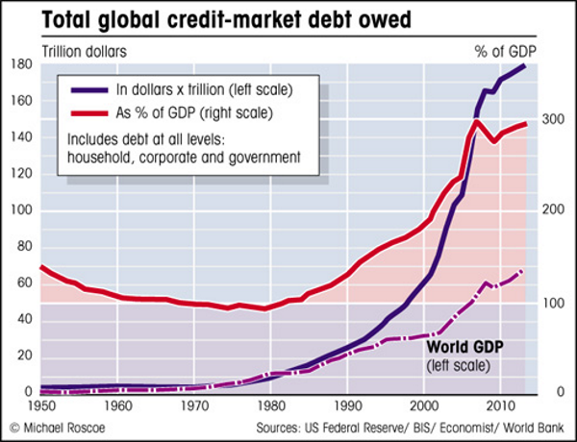
As mentioned above, this massive debt issuance is occurring against a backdrop of global growth that was already slowing. A recent FT article entitled “Global Outlook Collapsing Before Crisis”, reports on the latest results from the Brookings-FT Tracking Index for the Global Economic Recovery (TIGER). The index “compares indicators of real activity, financial markets and investor confidence with their historical averages for the global economy and individual countries. It showed historically large declines across financial indicators, real economic data and confidence indicators in March, well before the worst effects of the pandemic on the economies of most countries.”
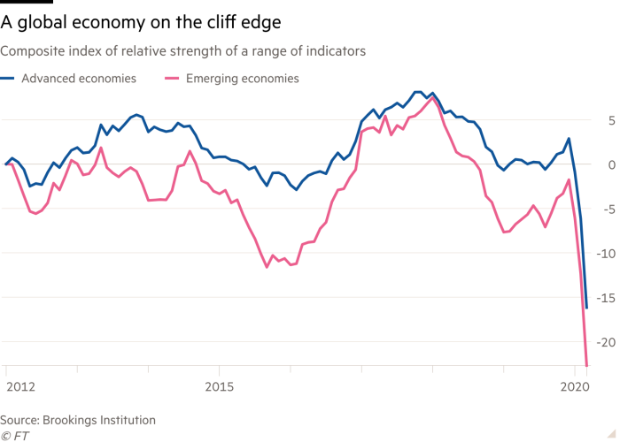
So there we are. A world awash in a swelling sea of debt, dwarfing the amount of output needed to generate the income to service the debt (let alone repay it), and the growth of that output has been declining. What could possibly go wrong? Then throw in a global pandemic and it really gets interesting.
Bob Rodriguez is a retired, award winning fund manager who ran top notch equity and fixed income portfolios for FPA Capital. He is an ever-astute observer of the financial markets. He recently wrote a letter entitled “Preliminary Thoughts – the New World Order”. He writes;
“Though the virus pandemic has been tumultuous, challenging and with little precedence, from a capital market perspective, this market collapse was quite predictable. Capital market excesses became pervasive in ways that were also unprecedented. Zombie companies, corporate operating strategies that elevated financial risk to extreme levels and consumers who also became highly leveraged were the accepted actions of the day...
Our economic and financial market systems were not prepared with appropriate “rainy day reserves” to withstand an exogenous shock. Balance sheets were stretched in all economic sectors. The shock to the US economy by the bombing of Pearl Harbor and the beginning of WW2 was more traumatic and of greater magnitude than what we are experiencing now and it would also last longer. However, after 12 years of Depression, the financial system was cleansed of speculative excesses that allowed for a financial re-leveraging of the economy to fight the war. After the carnage was over, the economy was able to grow out of an extreme leverage position. In contrast to then, this is not the case today, given that the economy is already extremely leveraged prior to the onset of the crisis…”
There are many ways of depicting the current carnage, but a few charts from Hedgeye research paint a pretty good picture:
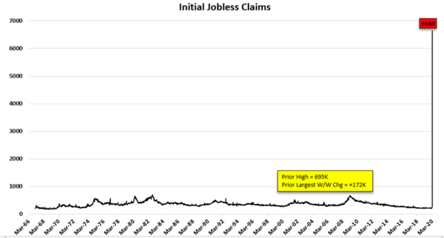

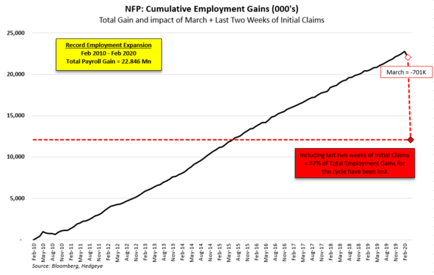

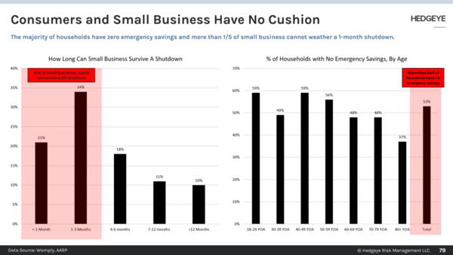

The first chart shows the stunning spike in initial jobless claims for people now out of work. Based on these numbers, the second chart shows that the current loss of employment has wiped away nearly 50% of total employment gains for the entire expansion dating back to 2010!
Hedgeye writes “The speed and scale of employment loss is staggering. As it stands, the job loss realized just these last two weeks is enough to push the unemployment rate up by ~6.5 percentage points (almost a triple relative to the current level). Is 20-30% Unemployment reasonable? Maybe/Maybe not …. as unimaginable as it seemed just a month ago, we’re already half-way there.” And, perhaps saddest of all, is the image above that evidences the comments above from Bob Rodriguez concerning stretched balance sheets:
And finally, because I can’t take much more, there’s this one from Hedgeye’s prolific, insightful and always entertaining cartoonist, B. Rich
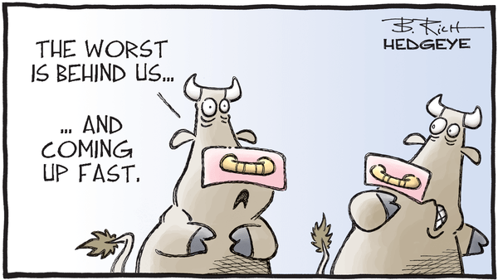
The pain of course, is being felt worldwide. The UN estimates that 195 million jobs will be lost globally. However, at least in the US, the immediate problem is more of a cash flow issue. This does not address the balance sheet problems, but in theory, the government can address cash flow and in practice, they’re giving it everything they’ve got. The recent CARES Act (Coronavirus Aid, Relief, and Economic Security Act) is a far-reaching, $2 trillion bill. It contains over 1,000 pages of text that detail the funding, loans, and tax provisions designed to provide economic relief to individuals, small businesses, hospitals – all designed to ensure and facilitate uninterrupted cash flow across a huge swath of the economy. This may not prove to be enough, but given that we have (or had) a $21 trillion economy and this bill equals 10% of it, I think it’s a solid start. There will most probably be more to come.
However, it’s the Fed’s balance sheet that interests us the most and here we just feel that it’s deja vu all over again - with just a few more zeros this time. In 2008, Ben Bernanke, Hank Paulsen and Timothy Geithner discovered that they could “save the world” from a massive debt implosion by merely replacing it with even greater amounts of debt. Of course, much of this debt was just transferred from the hands of private investors and onto the balance sheet of the Federal Reserve – a quasi-governmental entity – thus “socializing” the credit risk. But hey, it worked, and it worked so well that they did it four more times.
In 2015 under former Fed Chair Janet Yellen, the Fed decided to try and take back some of their previous largess and began gradually raising interest rates. The policy was continued under Fed chairman Jerome Powell up until 2018 when the stock market decided it had had enough of financial probity. As we wrote in our Q4 2018 Report, “The major indexes suffered their worst quarterly declines in roughly a decade, returning most benchmarks to levels last seen in the summer of 2017 and sending them into bear market territory, or down more than 20% from their recent highs”. This caused the Fed to have a sudden change of heart and in July of 2019 they began implementing what would become three successive rate cuts. By September they were back to expanding their balance sheet again, and were joined by major central banks around the world as the global economy began slowing.
Bloomberg noted then that “Net bond purchases by the Federal Reserve, European Central Bank and Bank of Japan will swing back above zero from September…That’s just eleven months since they collectively hit reverse having spent a decade pumping stimulus into their economies via quantitative easing. The outlook shows how quickly central banks have been forced to turn tail after spending much of last year leaning toward tightening monetary policy, only to now be looking to loosen it as the world economy slows. It also underscores how their balance sheets are likely to remain permanently larger than the pre-crisis years (emphasis added).
Prescient, but not nearly bold or imaginative enough. The FT recently reported that “(the) Federal Reserve’s balance sheet is expected to balloon to an unprecedented size this year after its dramatic interventions to protect capital markets and the world’s biggest economy from the effects of the coronavirus outbreak… Analysts at Bank of America say these actions, taken together, could result in the Fed’s balance sheet topping $9tn by the end of the year, or more than 40 per cent of US gross domestic product. Its balance sheet has already expanded by more than $1tn since the coronavirus outbreak began. That could prove an understatement. Krishna Guha, vice-chairman at Evercore ISI, expects the balance sheet to hit the $9tn milestone by mid-year.”
For now, Wolf Richter reported last week that “Total assets on the Fed’s weekly balance sheet jumped by $272 billion in one week, to $6.08 trillion, according to the Fed’s release Thursday afternoon. Since the Fed started this spree of Wall Street and asset-holder bailout programs four weeks ago, total assets have exploded by $1.77 trillion.” (see chart below)
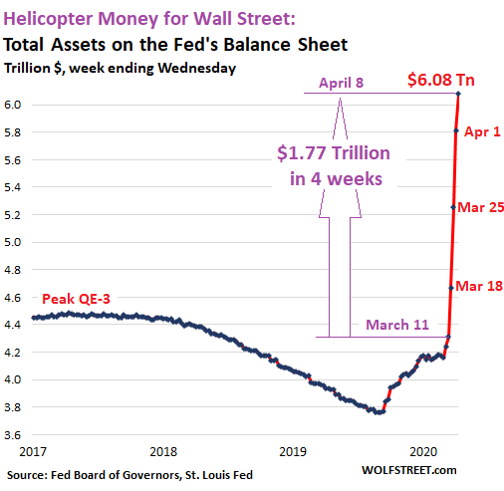
The statement from the chart seems obvious enough, but the full meaning is much deeper. Traditionally the Fed was only allowed to conduct its monetary policy through the purchase and sale of US government securities. Thanks to recently passed legislation, these recent purchases now include (or are allowed to include) commercial paper, corporate bonds, asset-backed securities, bond ETFs, and direct loans to small and medium sized businesses, all under a variety of an “alphabet soup” of newly created entities (e.g. the CPFF, TALF, PMCCF…). The details and mechanics of this are too nuanced to discuss here, but for an excellent explanation of the scheme, we would direct you to some of the work done by Jim Bianco (such as a recent piece published in the Washington Post on March 29, “The Fed’s Cure Risks Being Worse Than the Disease”).
Bianco writes “To put it bluntly, the Fed isn’t allowed to do any of this… (They) will finance a special purpose vehicle (SPV) for each (new program) to conduct these operations. The Treasury, using the Exchange Stabilization Fund, will make an equity investment in each SPV and be in a “first loss” position. What does this mean? In essence, the Treasury, not the Fed, is buying all these securities and backstopping of loans; the Fed is acting as banker and providing financing. The Fed hired BlackRock Inc. to purchase these securities and handle the administration of the SPVs on behalf of the owner, the Treasury. In other words, the federal government is nationalizing large swaths of the financial markets (emph. added)…This scheme essentially merges the Fed and Treasury into one organization.
In effect, the Fed is giving the Treasury access to its printing press…these acronym programs (if abused, as Bianco outlines) might indeed force markets higher than valuation warrants. But it would come with a heavy price. Investors would be deprived of the necessary market signals that freely traded capital markets offer to aid in the efficient allocation of capital. Malinvestment would be rampant. It also could force private sector players to leave as the government’s heavy hand makes operating in “controlled” markets uneconomic. This has already occurred in the U.S. federal funds market and the government bond market in Japan.”
Bob Rodriguez is even more direct:
“As for me, with the yesterday’s Fed announcement of unlimited QE and its ‘will buy or support almost anything,’ along with the pending passage of a $2-2.5 trillion stimulus package (ed. note, subsequently passed), this is the end of the capital markets as we have known them. We have now entered unlimited QE and MMT where there is no escape…once initiated, a reversal would be impossible.
“With the initiation of the Fed’s complete takeover and control of the US financial economy, there is now absolutely no accurate pricing discovery in the capital markets and we have entered a period of total manipulation. In light of this, the only markets I have an interest in are those where the heavy hand of government is not involved or only minimally involved…US capital markets, RIP!”
We are sympathetic to this view and share Rodriguez and Bianco’s concerns. Particularly Rodriguez’s earlier observation regarding the outcome of our indebtedness coming out of WW II and how we were able to grow out of it because “after 12 years of Depression, the financial system was cleansed of speculative excesses”. As a result, “After the carnage was over, the economy was able to grow out of an extreme leverage position”. In more recent times, we have never had this “cleansing”. It was not allowed to happen because our leaders “protected us” from it by facilitating an ever larger buildup of debt, or leverage. It should be noted that the discussion here has only extended to traditional debt and borrowing and so we’re only dealing in the trillions, such as the IIF’s estimate (see above) of $257 trillion of total global debt. We have not even touched upon the derivatives markets! The BIS (Bank for International Settlements – also discussed in past reports) which monitors these markets, estimates that “Notional amounts of OTC derivatives rose to $640 trillion at end-June 2019.” (It should be noted that after spiking sharply from 2007 through the first half of 2008, growth in these markets have seen fits and starts, but have been essentially flat for the past decade. Nevertheless, this is a continuation
of an increase evident since 2016, and we are rapidly flirting with levels in the quadrillions, whatever that is).
Where this ultimately brings us is anyone’s guess. And here, we completely agree with Howard Marks regarding “the total absence of guidance from analogies to the past”. Perhaps we come out of this with a less efficient, but “kinder and gentler” form of capitalism. Nevertheless, it is our belief that for the past decade – as a result of central bank/government intervention - the outcomes in the financial markets have become more and more divorced from the progress of the real economy. There have been pockets of tremendous innovation in areas such as genomics, artificial intelligence and technology, biotech and so on. And, at the same time, there has been a swell of “zombie companies” – highly indebted companies that don’t even earn enough to cover their interest payments! (Around the end of 2018, this equaled 13% of all companies in the advanced economies, according to BoA Merrill Lynch. A BIS study found that “…the prevalence of zombies has increased significantly since the 1980s… Across 14 advanced economies, their share rose, on average, from around 2% in the late 1980s to some 12% in 2016.”) The Russell 2000 Growth Index is an index of 2000 smaller companies. According to Janus Henderson, “The percentage of unprofitable companies in the index is now above 40% (you read that right) and is at its highest level in at least 15 years.”
Our strongest conviction at this point is that these trends remain intact – the result of the identical policies we’ve been employing since 2008. There is tremendous angst and uncertainty concerning the harm and suffering that will be visited by the coronavirus. This is rational and deserved. However, what’s not at all clear is whether this has to be reflected in financial markets – at least more than they’ve already been reflected. As Howard Marks wrote further, “The most important job is to strike the appropriate balance between offense and defense… One way to think about the balance between offense and defense is to consider the ‘twin risks’ investors face every day: the risk of losing money and the risk of missing opportunity.”
We fully agree. We have raised cash levels slightly in most accounts, from around 10% prior to the market collapse to roughly 20% currently and we’re comfortable with this allocation for now. However, according to a recent BoA/Merrill Lynch survey of portfolio managers, “Latest sentiment tests shows peak pessimism has been reached with almost all managers expecting a global recession… Fund managers’ cash levels have hit their highest point since the September 11 terrorist attacks, with almost all investors expecting a global recession in 2020.” This is evidence to us that perhaps we’ve seen the worst – at least as far as the stock market is concerned. The larger question remaining then is what sectors to allocate to. There’s a real possibility that the large US growth names that led the last decade – the “FAANG” stocks and technology in general – are already owned by everyone and are not the names that will lead for the next decade. For now, we are looking to the US dollar for our clues. IF it begins to weaken, that will be the sign to look to small-cap stocks, basic materials and commodities, and perhaps overseas. There are also a slew of names domestically in areas of “disruptive growth” referenced above that are a lot cheaper than they were a few months ago and are currently on our shopping list. We have made small purchases already and expect to continue into the spring and summer.
We wish all of our readers above all, good health and the equanimity needed to get through these truly challenging times. But get through, we will. We at Katonah Capital Group and Income & Asset Advisory are here to help in any way that we can. We’ve been reaching out to as many of you as possible and invite you to contact us if there’s anything you need from us.

Thank you for reading.

Jason

https://app.hedgeye.com/insights/80789-cartoon-of-the-day-sanitary?type=cartoons; Hedgeye Research Reports
Lowry Market Trend Analysis for the Week Ending March 27, 2020; pg. 1.
Data from TC2000
https://www.gsam.com/content/gsam/us/en/advisors/market-insights.html#section-background_2d70_background_sectionheaderwithtab
https://www.fa-mag.com/news/a-bottoming-process-begins--10-themes-to-consider-54669.html
https://www.cnbc.com/2020/03/31/stock-market-today-live.html
Ibid. #5.
https://www.oaktreecapital.com/insights/howard-marks-memos
https://en.wikipedia.org/wiki/Institute_of_International_Finance
https://www.cnbc.com/2020/01/14/global-debt-hits-all-time-high-of-nearly-253-dollars--iif-says.html
https://data.worldbank.org/indicator/NY.GDP.MKTP.CD
Op. cit. #9.
https://snbchf.com/2018/02/skoyles-debt-crisis-ii-cometh/goldcore_chart4_14-05-15-png/
“Global Outlook Collapsing Before Crisis”; FT, April 13, 2020; pg.2
https://www.ft.com/content/9ac5eb8e-4167-4a54-9b39-dab48c29ac6c
https://www.advisorperspectives.com/articles/2020/03/24/preliminary-thoughts-the-new-world-order
Hedgeye Market Edges; April 6, 2020; various pages.
Op. cit. #16
“Pandemic Will Destroy Equivalent of 195m Jobs Globally, Warns UN”; FT, April 8, 2020; pg.1
https://www.troweprice.com/financial-intermediary/us/en/insights/articles/2018/q4/quarterly-market-review.html?cid=BD_TP6A_BD_Play2&bid=128904226&PlacementGUID=em_USI_USI_MktActivation_Play2_MonthlyMarket_E6-BD_TP6A_BD_Play2_20190123
https://www.bloomberg.com/news/articles/2019-07-23/quantitative-tightening-to-end-as-central-banks-sound-retreat
“Emergency Purchases: Fed Relieves Strain but Balance Sheet Likely to Top $9tn by End of Year”; FT April 6, 2020; pg.6
https://wolfstreet.com/2020/04/09/qe-4-cut-in-half-this-week-but-still-1-8-tn-helicopter-money-for-wall-street-and-wealthy-in-4-weeks-of-federal-reserve-balance-sheet-money-printing-and-bailouts/
https://www.washingtonpost.com/business/on-small-business/the-feds-cure-risks-being-worse-than-the-disease/2020/03/27/56357a52-7023-11ea-a156-0048b62cdb51_story.html
Op. cit. #15
https://www.bis.org/publ/otc_hy1911.htm
https://www.cnn.com/2019/03/31/investing/stocks-week-ahead-zombie-companies-debt/index.html
https://www.bis.org/publ/qtrpdf/r_qt1809g.pdf
https://seekingalpha.com/article/4279910-for-small-caps-index-multiples-obscure-risks
Op. cit. #7; pg. 6
Fund managers’ cash levels have hit their highest point since the September 11 terrorist attacks, with almost all investors expecting a global recession in 2020.

