FIRST QUARTER 2019 ADVISORY INVESTMENT REPORT
~ “Live by the s̶w̶o̶r̶d̶ bubble, die by the s̶w̶o̶r̶d̶ bubble”

The central banks blinked and the market turmoil we experienced in Q 4 was put to rest. The markets rebounded strongly in Q I after the sharp selloff and are essentially back to the same levels as when the downturn began. We’ve written often about the “grand experiment” the Central banks around the world engaged in after the financial crisis of 2008. A whole new alphabet soup regime of policies – QE, TARP, TALF, FSP, PPIP, TSLF and on and on - was unleashed on the financial system in a desperate and determined attempt to keep the system afloat. The results of these experiments were unknown as were the consequences of eventually ending them. The jury is still out on the former, however, we now have a much clearer understanding of the effects of trying to back away from Quantitative Easing (let alone reverse it). As noted in last quarter’s report, the results were not pleasant. According to Jake Weber at Mauldin Economics, “From peak to trough, over $20 trillion of global equity market cap vanished (see chart below). It took less than 11 months to wipe out 23% of equity value”.
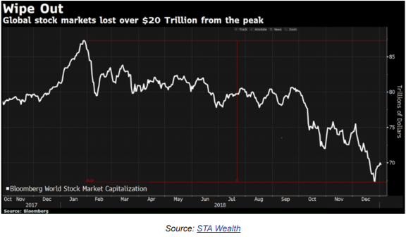
Clearly, this was a fight the Central Banks were not willing to stomach. Talk of monetary discipline quickly evaporated. The Fed was very public in their efforts to reassure the markets. According to T. Rowe Price, “The S&P 500 scored its best daily gain for the quarter on January 4, after Federal Reserve Chairman Jerome Powell stressed to a group of economists that the Fed would not hesitate to respond with all the tools at its disposal to counteract an economic downturn or financial turmoil (emph. added).”
The ECB was equally public and decisive in their retreat. They had ended their QE bond buying program in December 2018. This lasted all of a few months. According to Bloomberg, “The European Central Bank is beginning the process of admitting it made a policy mistake…Officials rightly acted swiftly to add more stimulus to the worsening euro zone economy on Thursday (note: 3/7/19). Pushing out rate guidance and restarting TLTROs were all welcome moves now that the idiosyncratic risks to growth are morphing into widespread damage.”
China was not as public in their actions, and the response was not the full blown quantitative easing (QE) that they engaged in during the last economic retrenchment in 2015-16. However, they implemented a number of easy policy responses such as lowering the amount of reserves (RRR) they required banks to hold (thus freeing up reserves for lending out). The charts below show the sharp drops in the RRR in June and October of 2018 and January of this year. Note the subsequent jump, with a lag of a month or two, in loan growth.
China Cash Reserve Ratio Big Banks
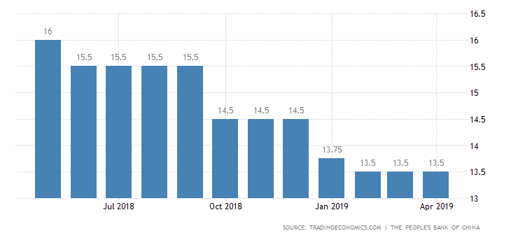
China Outstanding Yuan Loan Growth
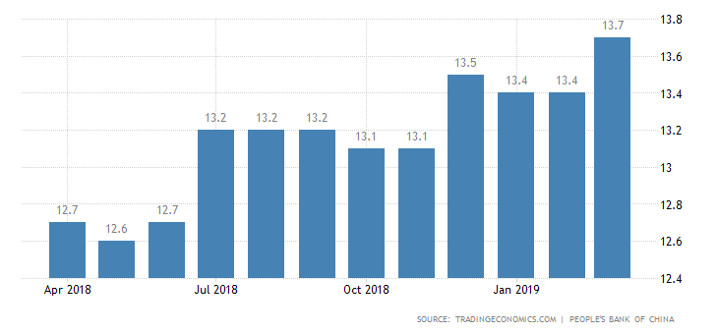

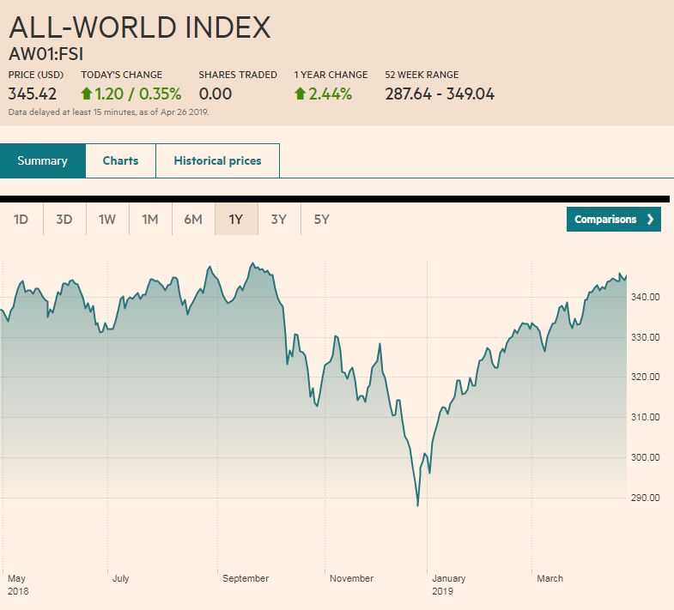

The results can be seen in the chart above from the FT showing their “All-World Index” of global equity values. Oops! What correction? The combined monetary magic did its work, the deep swoon in prices was reversed, the global financial system was saved, and all is well in River City once again! The million dollar question is, of course, how long can the central banks keep at this?
We explored this question in our last report. We wrote… The central banks absolutely need to “normalize” their balance sheets and sever our dependence on endless supplies of credit. There is no easy way out of this, but as often noted, markets correct via price or time. Perhaps the unfolding

slowdown will prompt the Fed bankers to proceed with their quantitative tightening (QT) ever so gradually. That could extend the cycle for years. As T. Rowe Price further noted, there is no sign on the horizon of a recession – at least in the US – but because of weaker global conditions “The Fed has completed most of its anticipated tightening, making further rate hikes less of a challenge. The auto and housing sectors in the U.S. have slowed as rates have risen, but the types of distortions that are typically apparent at the end of a market cycle are conspicuously absent—providing little threat of a boom being followed by a bust (emph. added). The current environment has not seen a widespread misallocation of capital and euphoria in certain sectors, such as occurred in telecom infrastructure in 1999 and housing in the mid‑2000s.”
In fact, recent economic numbers for the broad economy were robust. As JPMorgan noted, “1Q GDP surprised investors on the upside, growing at an annualized quarterly rate of 3.2%, handily surpassing consensus estimates of 2.3%. Despite the government shutdown earlier in the year and the fading effects of the tax cuts, the U.S. economy grew at a faster pace than the previous quarter’s 2.2%.” The bank economists note, however, that growth was boosted by several one-off factors like inventory growth and exports – two volatile components of GDP. They note further that “…final sales to domestic purchasers, which excludes these two components and gives investors a better read on the underlying growth pace, grew by only 1.4%. This is a step down from last quarter’s 2.1% and a significant decrease from the “sugar rush” 3.5% average of the middle of 2018… investors should welcome the confirmation that growth is not stalling, but should also be aware that a downshift is still occurring as expected.”
And, even assuming the business cycle does extend for much longer than anyone expects, that begs the next million dollar question which is what does it all mean for asset prices and the stock markets in particular. These two questions – regarding the course of the real economy vs. the health of the financial assets – are arguably more inextricably intertwined than ever. While the present economy is perhaps less vulnerable to the vicissitudes of traditional cyclical sectors such as autos or housing, it is more reactive than ever to financial asset values. In fact, the last two recessions were precipitated by the collapse of the NASDAQ tech bubble in 2002, and the collapse of the housing market and subprime debt in 2008 – both of which were financial events.
On the other hand, it is ironic that one of the longest bull markets in history exists on the back of one of the weakest economic recoveries on record. Many have traced the source for this squarely back to

central bank policies – both directly and indirectly – as they’ve been both direct buyers of financial assets as well as creators of the liquidity needed to float all financial boats. A prime example of the latter is the phenomenal growth of corporate share buybacks. Bloomberg recently reported on some research that Goldman Sachs put out on this. They write; “…Goldman Sachs started assessing an extreme scenario: ‘a world without buybacks.’ The picture doesn’t look pretty… corporate demand has far exceeded that from all other investors combined... Since 2010, net buybacks averaged $420 billion annually, while buying from households, mutual funds, pension funds and foreign investors was less than $10 billion for each...’Repurchases have consistently been the largest source of U.S. equity demand,’ the strategists wrote in a note Friday. ‘Without company buybacks, demand for shares would fall dramatically.’
As Jesse Felder noted in a recent report, “All of this new credit has enabled a massive debt-for-equity swap in which American companies, as a whole, have used new borrowing to buy back their own shares…This phenomenon has been so large and pervasive among public companies in America that it has represented essentially all of the net demand for equities for the past decade. It’s no coincidence that the Fed expanded its balance sheet by $4 trillion over the past decade and almost that exact amount has been manifest in stock buybacks.”
But, signs abound that the magic of central bank liquidity is waning and that the effects are merely increasing complacency in the face of declining credit quality and increasing risk appetite. One measure of this is in the amount of protection (or lack thereof) that investors demand before they will lend money to a borrower. In the world of corporate loans, these protections are called covenants. The higher the credit quality of the borrower, the less protection is needed; however, the amount of lower quality has been exploding. This type of debt is typically in the form of high-yield “junk” bonds and leveraged loans. Covenants on these loans can, for example, restrict borrowers from issuing even more debt, or can exact recourse if the borrower’s sales or cash flow fall below a certain level. When there’s too much liquidity chasing too few loans, the covenants tend to become weakened and the loans are called “covenant-lite” loans. Rating agencies like Moody’s and S&P track the quality of these and, as the charts below from Steven Blumenthal’s “On My Radar” indicate, the trends are alarming.
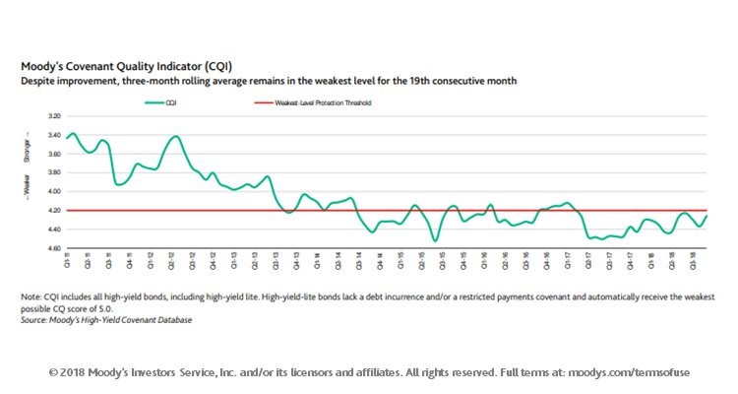

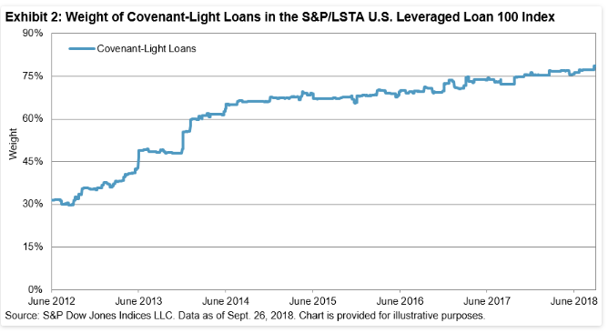
According to Blumenthal, the amount of high risk debt has grown to around $5 trillion right now and well over a trillion of is it leveraged loans. He writes, “The leveraged loan market is generally where companies whose credit is so weak they can’t access the high-yield bond market to obtain financing. Read that last line again. This is the sub-prime of the corporate bond market.” And, “Think about this for a second. Nearly one-third of the companies in the Russell 2000 Index are not making a profit. They are living on debt made available by the trillions that have flowed into leveraged loan, high yield bond and investment grade bond funds and ETFs. This is sub-prime on steroids.”
In the face of this uncertainty, some sentiment indicators are registering record amounts of complacency. One such measure – the “Volatility Index”, or VIX – measures the expected degree of price movement in a security. A low “vol” implies that traders are not expecting much violent price movement and they are selling (or even shorting) vol. This is symptomatic of bullish sentiment and lack of fear. When a market or security begins to fall or crash, the volatility measures spike up, fear reigns, and people scramble to buy vol as a hedge against their losses.
In a recent Hedgeye “Markets Edge” report, they have a section titled “An Epic Amount of Complacency?” where they report that speculative short positions on the VIX are at astoundingly high levels. They show the following:
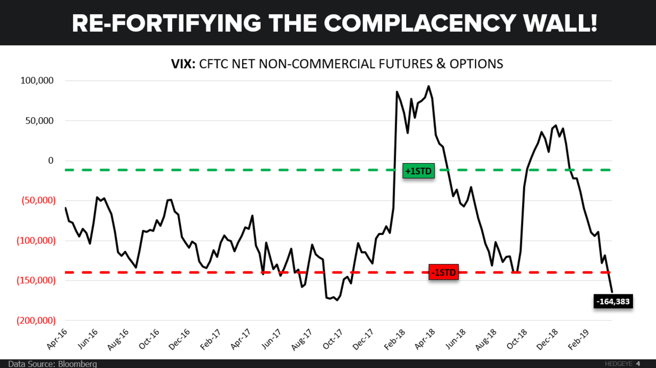

While this certainly heightens the risk of a shorter term market disruption, in our view the broader, longer term trends remain up. Given all the trillions of debt existing that has to be serviced, and given the Fed’s experience last quarter when they attempted to restrict the liquidity flowing into the debt markets, and given their ultimate response… it’s entirely possible that we continue along in this same slow growth environment we’ve experienced for the past decade. Growth in financial asset values should become more subdued, but neither should they crash. The experience of Japan for the past three decades could be instructive here.
Japan had their own Great Financial Crisis back in 1989. While there are significant differences between the history and subsequent policy responses of the Japanese experience versus that of the US in 2008, it’s entirely possible that the experiences do, and will, “rhyme”.
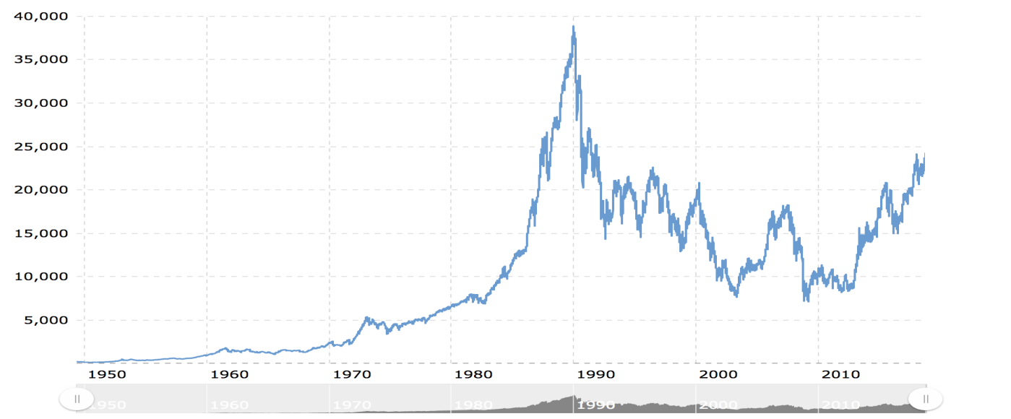

The above chart is of the Japanese Nikkei 225 stock market index. Although it’s recovered well in the past 5 years (also thanks to the QE of the Bank of Japan), it has yet to surpass its peak of almost 40,000 set three decades ago! According to a recent newsletter from John Mauldin, the Japanese debt-to-GDP ratio has risen to 253%. That is truly mindboggling. For reference, as of 2017 the debt-to-GDP ratio in the US was 105.4%. Further, Mauldin writes that “The Bank of Japan has more than 140% of Japanese GDP on its own balance sheet. Its laws let it buy equities not just in Japan but all over the world and it has.”
According to Mauldin though, “For the last two decades, the Japanese have been promising they would balance their budget in 7 to 10 years—and they’re actually beginning to make progress. Their fiscal deficit is in fact smaller every year in terms of GDP and actual numbers of dollars…The deficit should fall even further as they have a small sales tax increase kicking in the fall of this year…and sometime in the next decade, it is entirely possible that Japan will actually have a balanced budget, and then a surplus that lets the government begin paying down that debt.”
“Was it worth it?” Mauldin asks. His reply – “From one perspective, it has done quite well. From another, they have paid a cost…I think many Japanese, likely a big majority, would say yes.”! Mauldin make the further point – or prediction – that the bulk of all the massive amounts of US debt overhanging our economy (and society) will ultimately wind up on the balance sheet of the Federal Reserve bank. And similarly, the bulk of European debt, and UK debt, and so on, will wind up on the balance sheets of their respective central banks. The same as the path the Bank of Japan has already gone down.

This is something we’re just beginning to contemplate. If correct, the ramifications for portfolio management will be profound. It will mean that interest rates here too will trend down towards zero (as they’ve been in Japan for the past decade) as savers (and retirees) bail out the borrowers. Equities will bounce around in a more sideways trajectory with little overall gain in the indexes, but significant differences in individual equities and sectors. On the other hand, we could be entirely wrong and misguided on this! (It has happened before)! However, we think the results of the recent Fed attempt at QT are eye-opening and instructive. We will be exploring this in much greater detail in future reports.
In the meanwhile, we hope you all enjoyed the recent holidays and Spring Breaks. We’re bullish on springtime here and looking forward to green trees and longer, warmer days.

Thanks for Reading,

Jason

Jesse Felder; Seeking Alpha, April 25, 2019; https://seekingalpha.com/article/4256599-perils-pursuing-monetary-policy-explicitly-makes-economy-reliant-bubbles?isDirectRoadblock=false
For a primer on these programs, see “The Alphabet Soup of the Financial System Bailout” by Carol Hempfling Pratt; https://foleyhoag.com/~/media/Files/Publications/Generic/Bank_Accounting_and_Finance_042209.ashx
https://ggc-mauldin-images.s3.amazonaws.com/uploads/pdf/CTM_Jan_09_2019_4.pdf
https://www.troweprice.com/financial-intermediary/us/en/insights/articles/2019/q1/quarterly-market-review.html?cid=BD_TP9A1_BD_Play2A&bid=163706432&PlacementGUID=em_USI_USI_MktActivation_Play2_MonthlyMarket_E9-BD_TP9A1_BD_Play2A_20190416
https://www.bloomberg.com/opinion/articles/2019-03-07/ecb-stimulus-is-first-step-to-admitting-mistake-on-ending-qe
https://tradingeconomics.com/china/cash-reserve-ratio
https://tradingeconomics.com/china/loan-growth
https://markets.ft.com/data/indices/tearsheet/summary?s=aw01:fsi
https://www.troweprice.com/financial-intermediary/us/en/insights/articles/2018/q4/quarterly-market-review.html?cid=BD_TP6A_BD_Play2&bid=128904226&PlacementGUID=em_USI_USI_MktActivation_Play2_MonthlyMarket_E6-BD_TP6A_BD_Play2_20190123
JPMorgan Asset Management; Weekly Market Recap; 4/29/19; https://am.jpmorgan.com/blob-gim/1383452890099/83456/weekly_market_recap.pdf
https://www.bloomberg.com/news/articles/2019-04-08/goldman-considers-a-world-without-buybacks-it-looks-ominous
https://ggc-mauldin-images.s3.amazonaws.com/uploads/pdf/20190425_OMS_bubbles-Felder.pdf
https://www.cmgwealth.com/ri/on-my-radar-investors-are-willing-to-do-almost-everything-hy-price-trend-holds-the-key/
Ibid # 13.
Hedgeye; Market Edges: Week of 4/21/2019
https://btcdirect.eu/en-gb/what-is-the-bitcoin-bubble
Mauldin Economics; Thoughts from the Frontline - The Rules Will Change but That's (Probably) OK; Sat 4/20/2019
https://tradingeconomics.com/united-states/government-debt-to-gdp
Op. cit. # 17
Op. cit. # 17

